43rd President of the United States
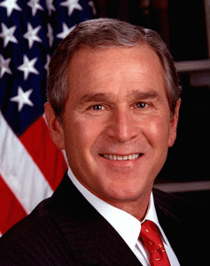

Commander-in-Chief George W. Bush
Chief Executive of the Executive Branch of the United States

