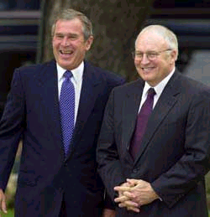
President Bush and Vice-President Dick Cheney

Dick Cheney stands in for the president and checks on Congress.

