Department Stores Vocabulary

- accessories | items that go with clothing, such as belts, shoes, hats, handbags, and wallets | 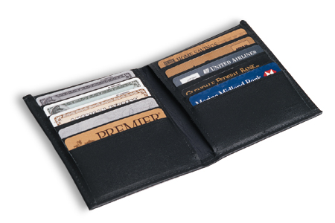  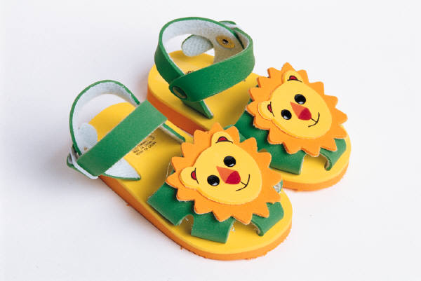
- apparel | (men’s, women’s, children’s)- another word for “clothing” | 
- catalog | a book with pictures of items that can be ordered thru the mail
- customer service | the area of a department store that gives information, and helps with layaways and catalog orders
- departments | the different areas of a department store; how a department store is divided
- electronics department | the department that sells electronic devices such as radios, televisions, and computers | 
- house wares department | the department that sells items for the home such as linens, cookware, and decorative items
- jewelry | the department that sells bracelets, rings, necklaces, watches, and earrings | 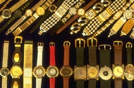
- layaway | a plan in which a buyer pays a deposit to reserve an item and makes regular payments to the store. They may pick up the item once they have made all of the payments.
- linens | refers to items such as bed sheets, tablecloths, and napkins
- sales clerks | the person who helps you in the store
- sporting goods department | the department that sells sports equipment, such as balls, skates, and rackets. |  | 

