The Voyage of Columbus

Map Skills

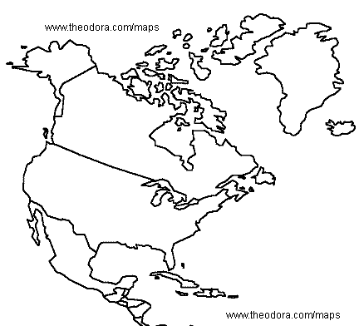

- Label the following on the map: Spain, Canada, United States of America, Cuba, Atlantic Ocean

- Spain is part of the continent of __________________.

- Mexico, Cuba, Canada, and the United States are all part of the continent of ____________________________.

- Where did Columbus begin his voyage? ________________

- Draw a line showing his voyage. Do you think he landed in Cuba or San Salvador?

- Label the compass: North, South, East, West, Northeast, Northwest, Southeast, and Southwest. In which direction did Columbus sail? ______________________.

