Citizenship Day Vocabulary

- citizen | a member of a country | 
- citizenship | state of being a member of a country and having rights because of it | 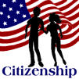
- Citizenship Day | a special holiday to honor all of the United States citizens; it is celebrated on September 17 each year
- honor | to respect or celebrate | 
- immigrant | a person who comes to a new country to live permanently | 
- immigrate | to move to a country to live there permanently | 
- Statue of Liberty | a statue in New York Harbor who represents freedom | 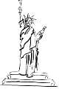
- responsibility | something that one should do | 
- right | freedoms, liberties, or privileges | 

