Understand Blizzards Vocabulary

- blizzard- | the most dangerous type of winter storm with heavy snowfall and winds at 35 miles per hour or more
- blowing- |  | using air to move something  The wind was blowing the leaves.
- freezing rain- | rain that falls through freezing temperatures and turns to ice when it lands
- heavy snowfall- |  | a lot of snow has fallen  There was heavy snowfall over the weekend.
- high/strong winds- |  | fast winds  The strong winds blew the trees.
- pile up- |  | when objects are thrown together  He piled up the leaves and jumped in them.
- sleet- | a mixture of rain and snow
- slippery- |  | causing to slide or slip  The ice is slippery.
- snowdrift- | 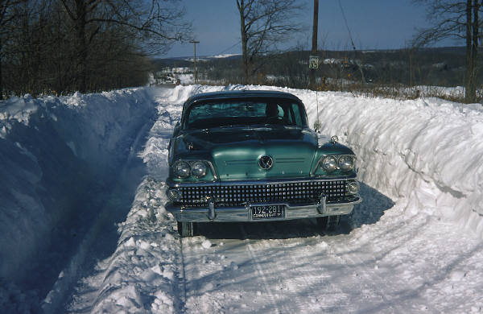 | a bank of snow piled up by the wind
- whiteout condition- | when the wind is blowing and it is snowing a lot and all you can see is white snow
- wind chill- | when the wind makes the air feel colder than it really is
- winter storm- | a storm with wind, freezing rain, sleet, or snow

