Name Articles of Clothing Vocabulary

- coat | 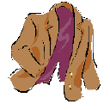 | Wear your coat. It’s cold outside!
- dress | 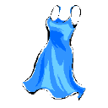 | Sue is wearing a blue dress to the party.
- jacket | 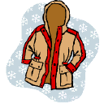 | Put on a jacket. It’s chilly outside.
- jeans | 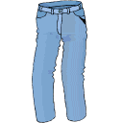 | Most people do not wear blue jeans to work.
- pants | 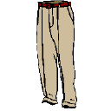 | Where are my brown pants?
- shirt | 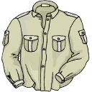 | This is a nice shirt.
- shoes | 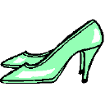 | I need a new pair of shoes.
- socks | 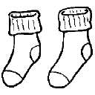 | These socks are white.
- suit | 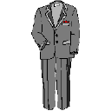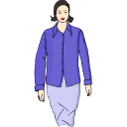 | Wear a suit when you want to dress up.
- sweater | 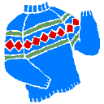 | I like to wear sweaters when it’s cold outside.
- t-shirt | 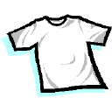 | I like to wear t-shirts when I’m at home.
- underwear | 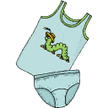 | This is boys’ underwear.

