The Story of President Abraham Lincoln

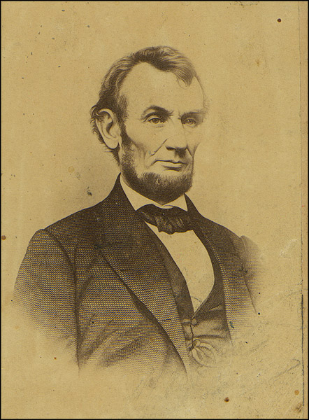
Abraham Lincoln was born on February 12, 1809, in Kentucky. He lived in a log cabin in the wilderness. His family was poor.

He became the 16th president of the United States in 1860. He was the president during the Civil War from 1861 - 1865.

He was shot by John Wilkes Boothe on April 14, 1865. He died the next day.

He was one of the greatest leaders in America. His birthday is celebrated every year on Presidents' Day.
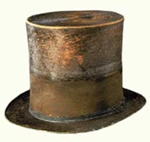
He is known for his tall build and his stovepipe hat. He is remembered for being honest and believing that all people are created equal.

