Abraham Lincoln Vocabulary

- Abraham Lincoln | the sixteenth president of the United States of America
- Civil War | a war in the United States that was from 1861 until 1865 when the states fought against each other
- John Wilkes Boothe | the person who shot Abraham Lincoln
- log cabin | a small home made of large pieces of trees
- poor | without money
- Presidents' Day | the day that we celebrate George Washington's birthday and remember other presidents of the United States
- stovepipe hat | 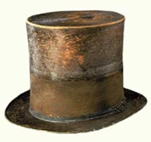  a special kind of hat worn by Abraham Lincoln
- wilderness | land where there are trees, plants, and wild animals, but not a lot of people living there

