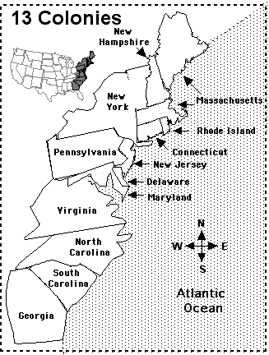
Map of the Thirteen Original Colonies

