Blizzards and Winter Storms

A winter storm is a storm with wind, freezing rain, sleet, or snow.

A blizzard is a severe winter storm with fast winds. These fast winds cause blowing snow. This makes it hard to see outside.

Winter storms and blizzards are very dangerous. The snow, ice, and sleet make roads slippery. Do not drive during a blizzard.

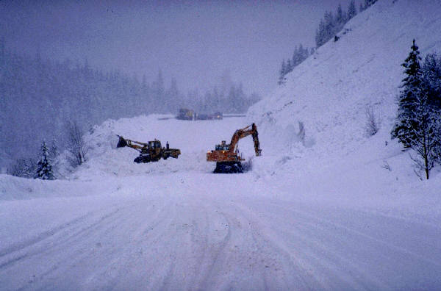
The air is very cold during a winter storm or blizzard. Stay inside and wear warm clothes to keep warm.

