The White House

The White House is the official home of the leader of our country. The leader is known as the President of the United States.

The White House is located in Washington, D.C. Washington, D.C. is the capital of the United States.

The White House has six floors. The President and his family live on two floors.

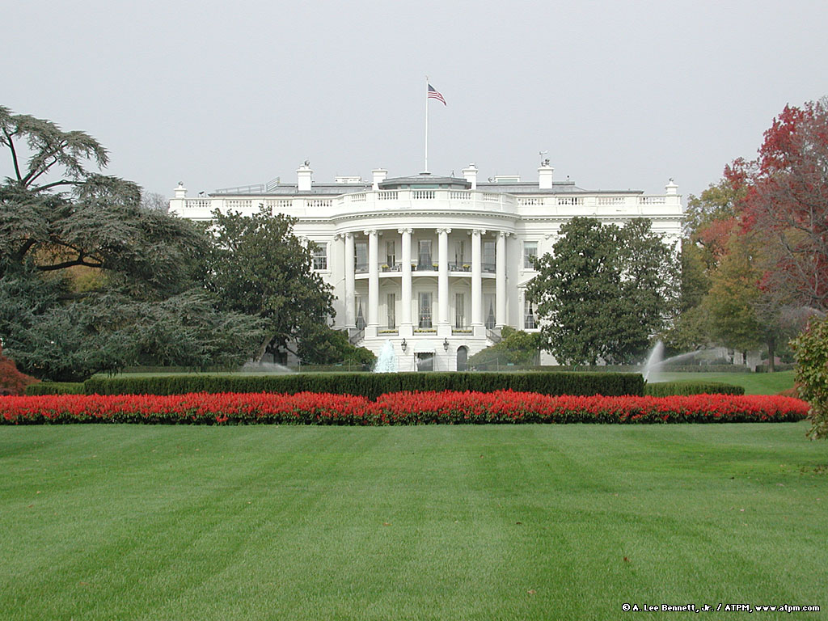
The President has an office in the White House. The office is called the Oval Office. This is where the President works.

