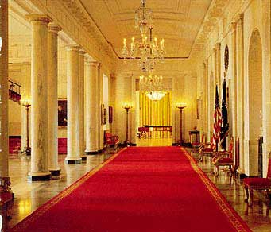

The East Room

Entrance and Hallway

