The Washington Monument Vocabulary

1. George  Washington | the first president of the United States
2. monument | something made in honor of a person, event, or achievement
3. stone | rock | 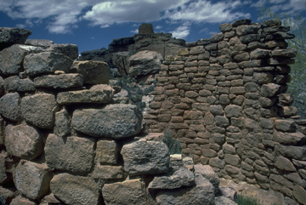
4. structure | a building
5. Washington  Monument | a very tall stone structure in Washington, D.C. with 4 sides | 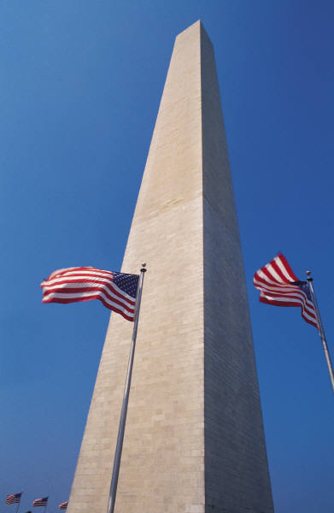
6. Washington, D.C. | the capital of the United States

