The Washington Monument
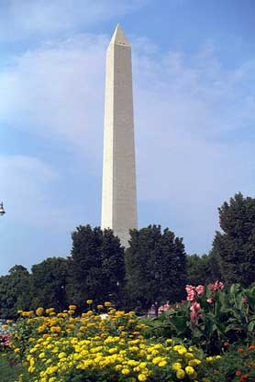
The Washington Monument is a very tall structure. It has four sides. The monument is made of stone.

It is located in Washington, D.C.

The Washington Monument was built to honor President George Washington.

There are 50 flags that circle the Washington Monument. The flags represent the 50 states.

