Volcanoes

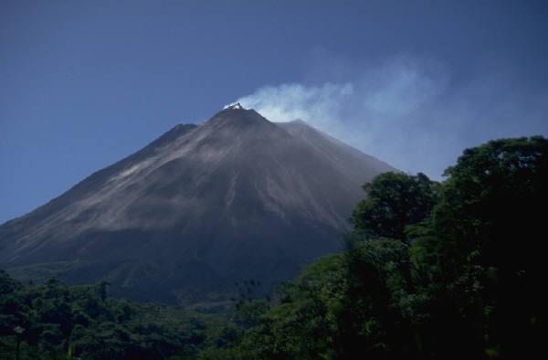
A volcano is a place where melted rock and gases erupt through the ground.

A volcano usually looks like a mountain.

Lava, volcanic ashes, and hot gases come out of the volcano when it erupts.

Volcanoes are very dangerous. Lava from a volcano will destroy everything in its way.

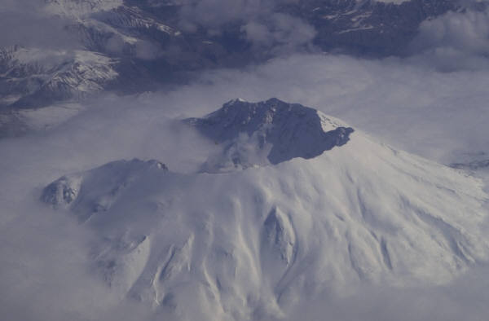
A volcano may not erupt for many years.

