Paper Currency

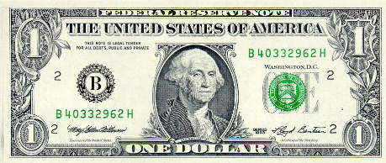
one dollar

(front)

$1.00

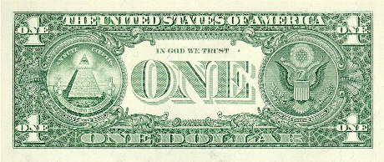

one dollar

(back)

$1.00

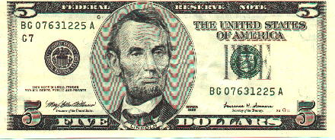

five dollars

(front)

$5.00

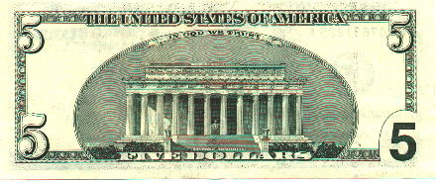

five dollars

(back)

$5.00

Paper Currency Continued

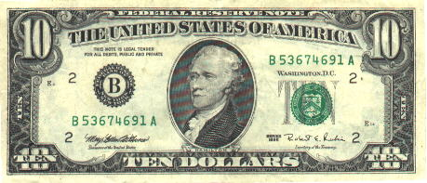
ten dollars

(front)

$10.00

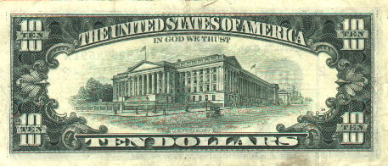

ten dollars

(back)

$10.00

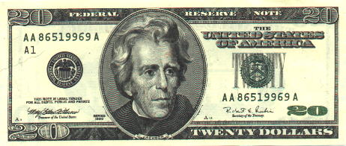
twenty dollars

(front)

$20.00

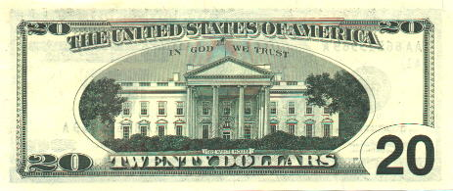

twenty dollars

(back)

$20.00

Paper Currency Continued

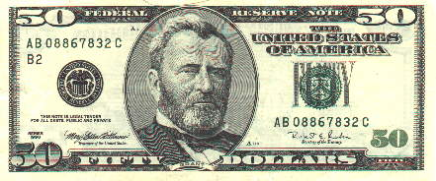
fifty dollars

(front)

$50.00

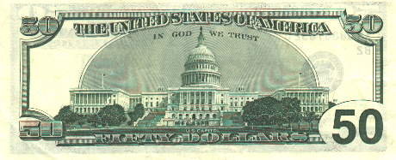

fifty dollars

(back)

$50.00

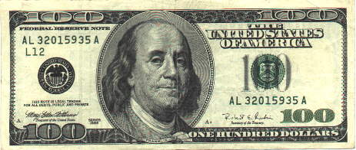
one-hundred dollars

(front)

$100.00

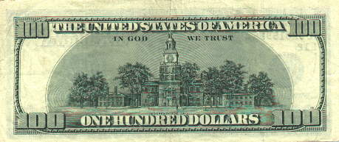
one-hundred dollars

(back)

$100.00

