Traffic Signs

Matching

Write the number of the sign beside the correct meaning.

1. 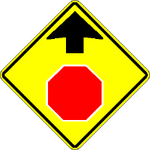 2. 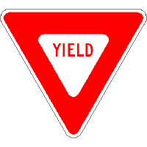 3. 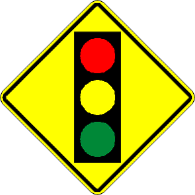 4. 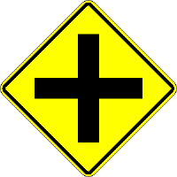

5. 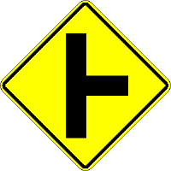 6. 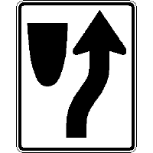 7. 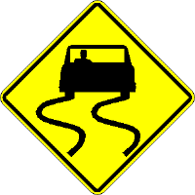 8. 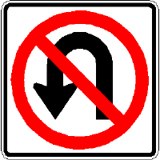 9. 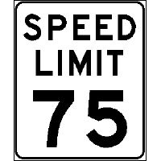

- Keep right
- Crossroad ahead
- Yield
- Right side road ahead
- Stop sign ahead
- Speed limit sign
- No U turn sign
- Slippery when wet sign
- Stop light ahead

