Tornadoes
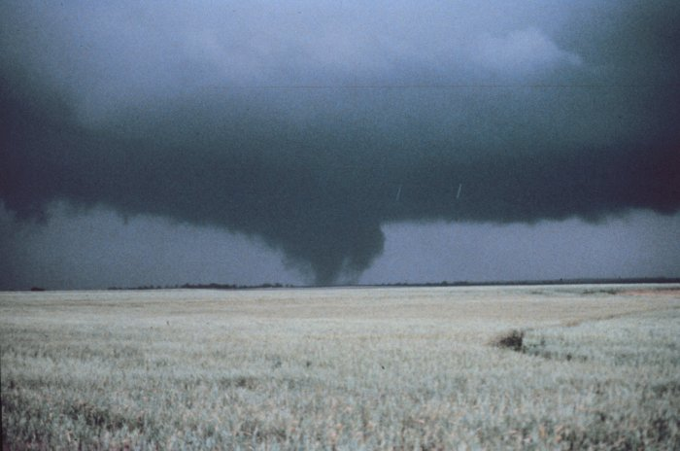

Tornadoes are dangerous storms. The winds in a tornado are very fast. A tornado can move people and objects high into the air. Tornadoes can destroy everything in their path.

Tornadoes can happen when air in a thunderstorm starts to move counterclockwise. The direction of the air movement forms a funnel cloud.

Tornadoes can happen any time of year. Tornado season is April, May, and June. There are more tornadoes in these months.

