The United States Supreme Court

The Supreme Court is in Washington, D.C. It is the highest court in the United States. The most important thing that the Supreme Court does is to protect the Constitutional rights of people. They do this by deciding if laws are allowed by the Constitution.
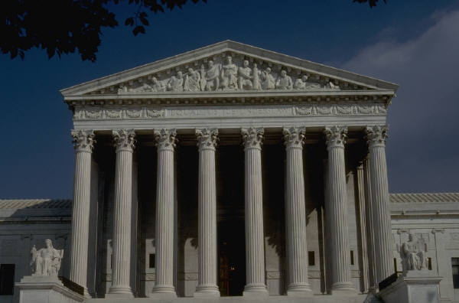

Front of the Supreme Court Building

The Supreme Court has 9 judges who are called justices. One of the judges is more important than the others and is called the Chief Justice. The President of the United States chooses all of the justices.

