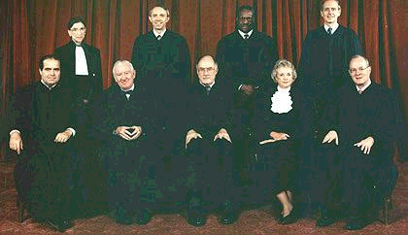

The 9 United States Supreme Court Justices

