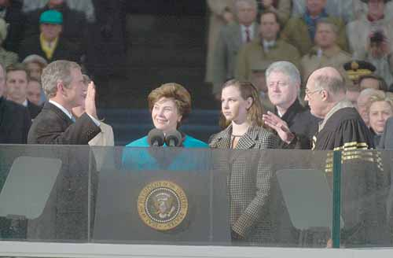

Chief Justice Rehnquist Swearing in President George W. Bush

