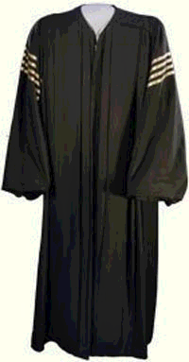

Supreme Court Chief Justice Robe

