The Statue of Liberty

Vocabulary

- crown | A wreath or band for the head
- France | A country in Europe | 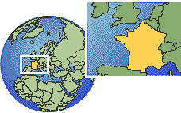
- landmark | An important building or monument
- liberty | The same as freedom; being free
New York City | A city in the state of New York
- spikes | Pointed parts of an object
- statue | A sculpture that usually represents a person or animal | 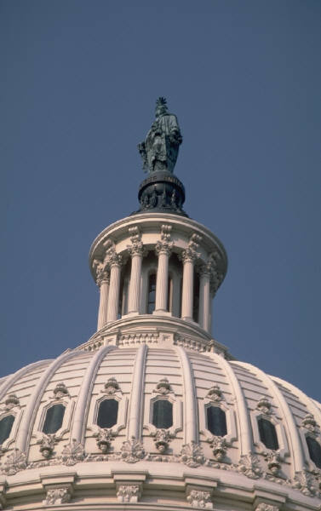  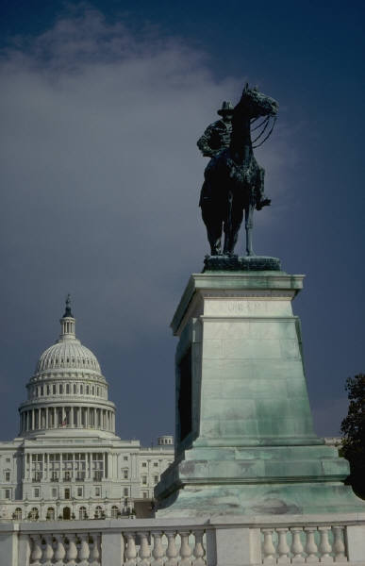
- torch | A flaming light made of something that burns brightly and usually is carried in the hand

