The Statue of Liberty

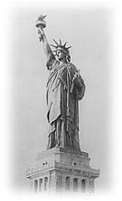
The Statue of Liberty is one of the most famous landmarks in the United States.

It is a symbol of freedom in the United States.

The Statue of Liberty is in New York City. It is a statue of a woman. The woman holds a torch. The torch represents liberty.

She wears a crown of seven spikes. The spikes represent the seven seas and the seven continents.

The Statue of Liberty was a gift of friendship from the people of France in 1886.

