Spring Weather Matching

Draw a line from the word to the correct picture.

1. sunny

2. windy

3. partly cloudy or
partly sunny

4. rainy

5. warm

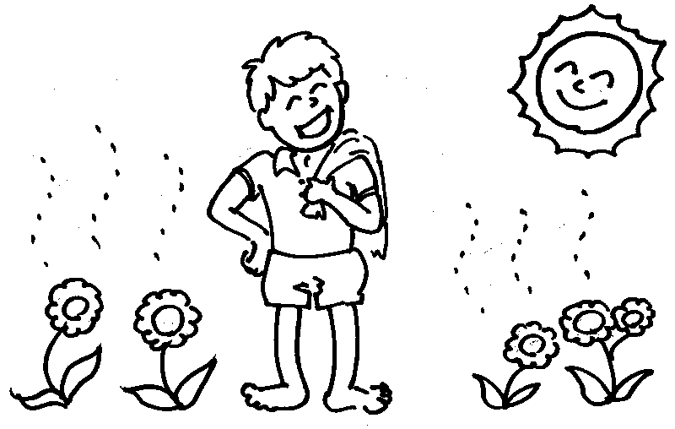
6. cloudy

