NORTH CAROLINA
SENATOR
JOHN EDWARDS
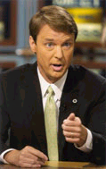
DEMOCRAT

