NORTH CAROLINA
SENATOR
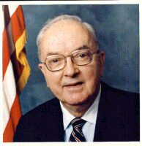
JESSE HELMS
REPUBLICAN

