The National Motto

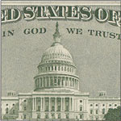
The National Motto is one symbol of the United States.

In 1956 a law made "In God We Trust" the National Motto of the United States.

"In God We Trust" was first used in the 1860's.

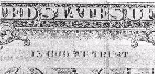
The National Motto "In God We Trust," is now on all coins and paper money in the United States.

