CHIEF JUSTICE
WILLIAM H. REHNQUIST
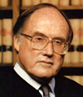

ASSOCIATE JUSTICE
CLARENCE THOMAS

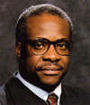
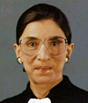

ASSOCIATE JUSTICE
RUTH BADER
GINSBERG
ASSOCIATE JUSTICE
STEPHEN G. BREYER

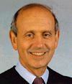
ASSOCIATE JUSTICE
JOHN PAUL
STEVENS
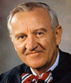

ASSOCIATE JUSTICE
SANDRA DAY

O'CONNOR
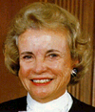

ASSOCIATE JUSTICE
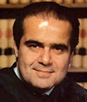
ANTONIN SCALIA

ASSOCIATE
JUSTICE
ANTHONY M.
KENNEDY

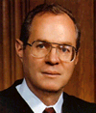
ASSOCIATE JUSTICE
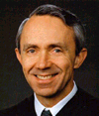
DAVID H. SOUTER

CURRENT UNITED SUPREME COURT JUSTICES
