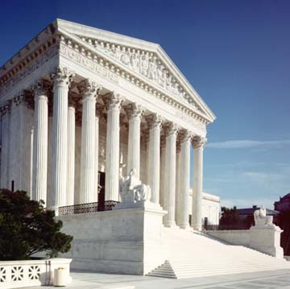
UNITED STATES SUPREME COURT BUILDING

