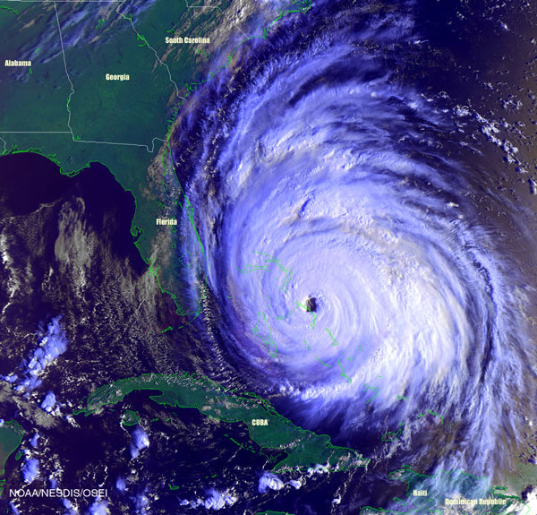
Hurricane in the Atlantic Ocean

