Hurricanes

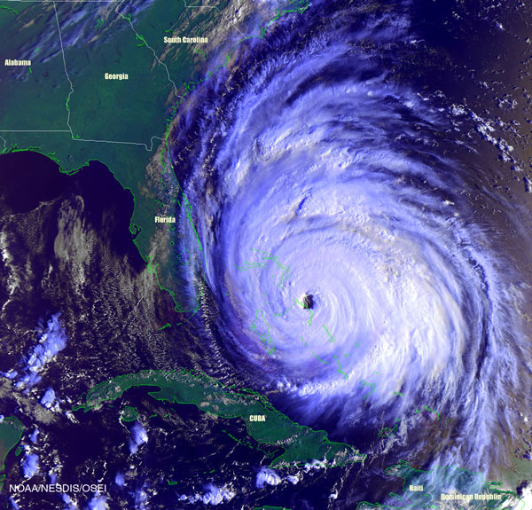
A hurricane is a very large storm. It forms over the ocean.

Most hurricanes are round. They are about 500 miles wide.

Hurricanes have large amounts of water and fast winds. This makes hurricanes very dangerous. A hurricane can destroy objects in its path.

Hurricane season is when most of the hurricanes happen. Hurricane season is from June through November.

