The Great Seal

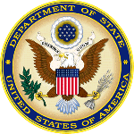
The Great Seal was created to symbolize the America’s beliefs. The people who gave us our freedom created it.

There are 2 sides of the Great Seal. You will learn about the front side.

In the center of the seal is a bald eagle, our national bird. There are 13 stars above the eagle. There are 13 stripes in the shield. There are 13 arrows in one of the eagle’s claws. There are 13 branches in the other claw. There are 13 letters in the motto. There are 13 of each of these to represent the first 13 states.
The Great Seal is used by our government on many important papers. It is used as part of the President’s seal. It is used on government agreements and laws.
Both sides of the Great Seal are used on the one dollar bill.
