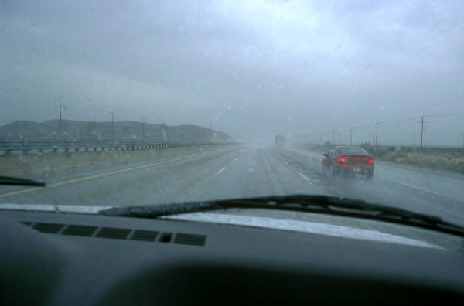
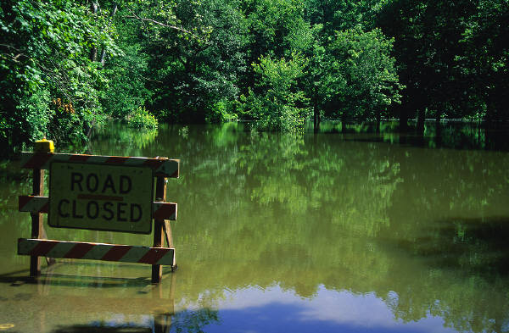

Floods can happen when it rains a lot. Roads that are flooded are dangerous.
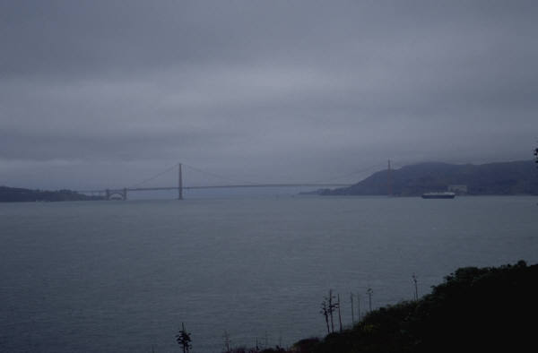
Floods
A flood happens when water runs over
dry land. This can happen when it is
raining a lot or when rivers overflow.
It can also happen when water comes out
of the ocean or when snow melts too fast.

Floods are very dangerous. Do not walk
or drive through flooded areas.
Floods can happen when rivers overflow.

