43RD PRESIDENT OF
THE UNITED STATES
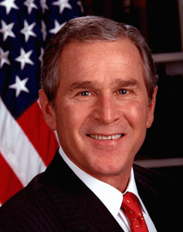

COMMANDER-IN CHIEF BUSH
CHIEF EXECUTIVE OF THE EXECUTIVE BRANCH OF THE UNITED STATES

