PRESIDENT BUSH &
VICE -PRESIDENT DICK CHENEY
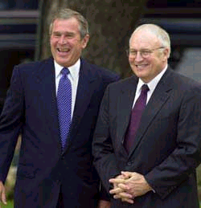
DICK CHENEY STANDS IN FOR THE PRESIDENT & CHECKS ON CONGRESS

