SECRETARY OF STATE
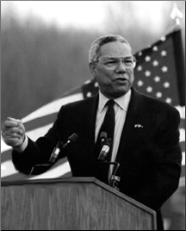
GENERAL COLIN POWELL
GENRAL COLIN POWELL HELPS
PRESIDENT BUSH GUIDE THE COUNTRY

