SECRETARY OF DEFENSE
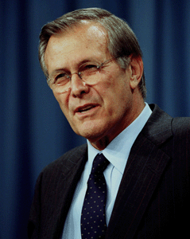
DONALD RUMSFELD

DONALD RUMSFELD HELPS THE PRESIDENT PROTECT AMERICA

