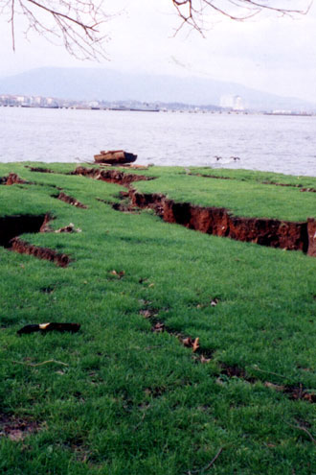
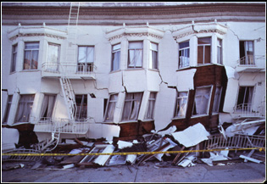
An apartment building in San Francisco with heavy damage from a 1989 earthquake

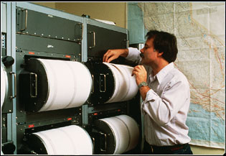
Cracks in the ground
from an earthquake
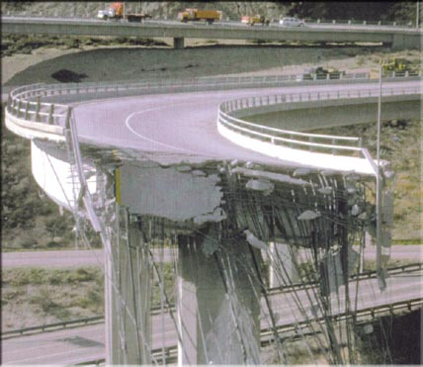

Seismograph machine
used to detect ground tremors

Collapsed freeways in California
after an earthquake

