Earthquakes

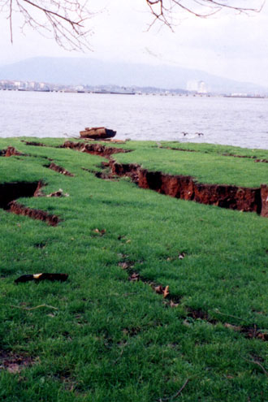
An earthquake is the sudden movement of the ground.

Earthquakes happen when rocks move under the ground.

Earthquakes can happen any time of year. No one knows when a quake will happen.

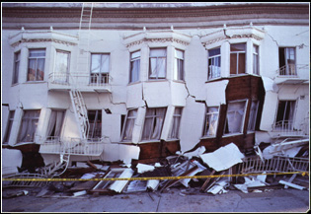
Earthquakes are very dangerous. An earthquake can destroy buildings and bridges.

Earthquakes usually last only one minute.

