Weekends and Weekdays

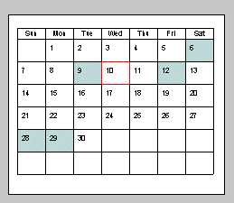
Weekend

Saturday

Sunday
Weekday

Monday

Tuesday

Wednesday

Thursday

Friday

