How to Count Coins

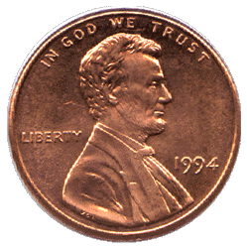
= 1 Count pennies by 1.

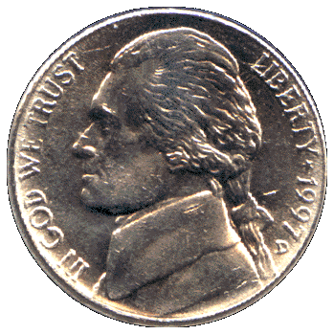
= 5 Count nickels by 5.

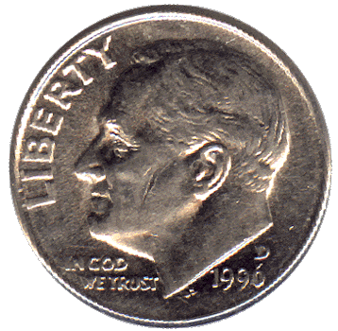
= 10 Count dimes by 10.

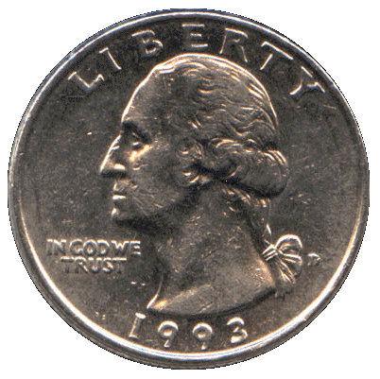
= 25 Count quarters by 25.

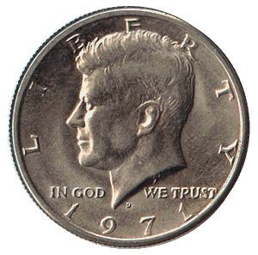

= 50 Count half dollars by 50.

