

ESL/Civics Education Project
Caldwell Community College and Technical Institute

Basic Skills Department
May, 2002

United States Citizenship
Student Version, Beginning Level

Citizenship Manual
Student Version

Beginning Level

Table of Contents

- Coming to the United States | Pages 3-12
- What Is a United States Citizen? | Pages 13-22
- Two Ways to Be a United States Citizen | Pages 23-30
- The Naturalization Process—Requirements | Pages 31-41
- The Naturalization Process—Things You Have to Do | Pages 42-52
- Rights of United States Citizens | Pages 53-61
- Responsibilities of United States Citizenship | Pages 62-71
- Glossary | Pages 72-80

Coming to the
United States

Coming to the United States

Vocabulary

- citizens | people who are members of a country
- descended | to have come from a person in the past
- except | not including
- immigrants | people who come to another country to live permanently
- immigrated | to have come into a country to permanently live
- Native Americans | American Indians  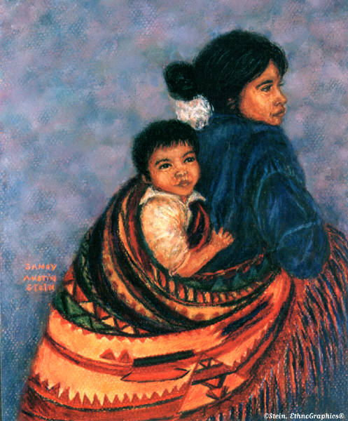
- permanently | forever

Coming to the United States

People who come to the United States to live permanently are called immigrants. Many people have immigrated to the United States. These people have come from many countries. Some of the countries that immigrants have come from are Mexico, Vietnam, Russia, Italy, El Salvador, Nigeria, and Columbia.

Except for Native Americans, all of the people living in the United States are descended from immigrants.

People come to live in the United States for many reasons. They come to live in freedom, to live in a safe place, or to make better lives for themselves and their families.

Many people who come to live in the United States want to become United States citizens.

Coming to the United States
Vocabulary Matching

Draw a line from the word to the correct definition.

- Native Americans | people who come to another country to live permanently
- citizens | forever
- descended | to have come into a country to permanently live
- except | not including
- immigrants | American Indians
- immigrated | people who are members of a country
- permanently | to have come from a person in the past
Coming to the United States
Writing Practice

Write the words.

- citizens
- descended
- except
- immigrants
- immigrated
- Native Americans
- permanently

Coming to the United States
Spelling Practice

Write the correct letter in the blanks.

- im__igrants

- Nati__e Americans

- excep__

- __mmigrated

- citi__ens

- per__anently

des__ended
Coming to the United States
Circle the Word You Hear

- Americans | Native Americans | America
- citizens | city | color
- immigrate | improve | immigrated
- easy | except | extra
- purple | permanently | period
- native | natural | number
- citizens | except | descended
- permanently | immigrated | immigrants

Coming to the United States

Conversation

Student 1 | Hi, I am from _________________. Where are you from?
Student 2 | I am from _____________________.
Student 1 | I am an immigrant.
Student 2 | What does that mean?
Student 1 | That means that I am from another country, and I have come to the United States to live permanently.
Student 2 | I am an immigrant, too. Why did you come to the United States to live?
Student 1 | I came here to live in freedom and to make a better life for myself. Why did you come here?
Student 2 | I came here to live in a safe place and to make a better life for myself.
Student 1 | The United States is a great place to live. I am glad that I am here.
Student 2 | I am glad that I am here also.

Coming to the United States
True or False

Circle T if the sentence is true. Circle F if the sentence is false.

T | F | - Some people come to the United States to live in a safe place.
T | F | - There are no immigrants in the United States.
T | F | - Native Americans are immigrants.
T | F | - Many people who come to live in the United States want to become citizens.
T | F | - Some people come to the United States to live in freedom.
T | F | - Mexico is a country that some immigrants come from.
T | F | - All immigrants come from Japan.
T | F | - Some immigrants come from Italy, Russia, and Vietnam.

Coming to the United States
More Writing Practice

Write each of the following sentences.

- I am an immigrant.
2. My friend immigrated from Vietnam.
3. Many people have immigrated to the United States.
4. I came to the United States to live in freedom.
5. I want to become a United States citizen.

What Is a United States Citizen?
What Is a United States Citizen?

Vocabulary

- citizen | a person who is a member of a country
- community | a place where people live and work
- country | the land of a group of people united by the same government

What Is a United States Citizen?
Vocabulary
Page 2

- government | the people elected to lead a country, state, county, or city | 
- improve | make better
- loyal | being true to one’s family, friends, or country
- member | a person who belongs to a group
- rights | freedoms, liberties, or privileges

What Is a United States Citizen?

A citizen is a person who is a member of a country. A United States citizen is a member of the United States of America.

A good citizen is loyal to the United States. A good citizen helps improve his or her community. A good citizen also helps improve the government. A citizen is given rights by the United States.

What Is a United States Citizen?

Vocabulary Matching

Draw a line from the word to the correct definition.

- loyal | the people elected to lead a country, state, county, or city
- community | the land of a group of people united by the same government
- citizen | make better
- government | being true to one’s family, friends, or country
- member | a place where people live and work
- improve | a person who is a member of a country
- country | a person who belongs to a group
- rights | freedoms, liberties, or privileges

What Is a United States Citizen?
Writing Practice

Write the words.

1. citizen
2. community
3. country
4. government
5. improve
6. loyal
7. member
8. rights

What Is a United States Citizen?
Spelling Practice

Write the correct letter in the blanks.

- c i __ i z e n

- c o m __ u n i t y

- c o u n __ r y

- g o __ e r n m e n t

- i m __ r o v e

- l o __ a l

- m e __ b e r

- __ i g h t s

What Is a United States Citizen?

Circle the Word You Hear

1. number | member | remember
2. improve | important | remove
3. county | counting | country
4. royal | loyal | jello
5. country | county | community
6. citizen | city | school
7. night | rights | right
8. government | going | goat

What Is a United States Citizen?

Conversation

Student 1 | Hi, my name is ______________.
Student 2 | Hello, nice to meet you. My name is ________________________.
Student 1 | Where are you from?
Student 2 | I am from ____________________. Where are you from?
Student 1 | I’m from ______________________. How long have you been in the United States?
Student 2 | I have been here ________________. How long have you been here?
Student 1 | I’ve been here __________________.
Student 2 | Oh, are you a United States citizen?
Student 1 | No, I want to be. Are you?
Student 2 | Yes, I just became a citizen.

What Is a United States Citizen?
More Writing Practice

Write each of the following sentences.

- I live in the United States.
2. My friend is a citizen of the United States.
3. I want to be a citizen of the United States.
4. A good citizen is loyal to the United States government.
5. A citizen is given rights by the United States.

Two Ways to Be a United States Citizen

Two Ways to Be a United States Citizen
Vocabulary

- natural citizen | a person who is born in the United States or whose parents are United States citizens
- naturalized citizen | a person born in another country who completes the naturalization process
- completes | finishes
- naturalization process | the way for people who were not born in the United States to become citizens
- process | way

Two Ways to Be a United States Citizen

There are two ways to be a citizen of the United States. One way is to be a natural citizen. The other way is to be a naturalized citizen.

A natural citizen is a person who is born in the United States.
If you were born in another country and have parents who are United States citizens, you are also a natural citizen.

A naturalized citizen is a person born in another country who completes the naturalization process.

Two Ways to Be a United States Citizen
Matching

Draw a line from the word to the correct definition.

- completes | a person who is born in the United States or whose parents are United States citizens
- natural citizen | way
- naturalization process | a person born in another country who completes the naturalization process
- naturalized citizen | the way for people who were not born in the United States to become citizens
- process | finishes

Two Ways to Be a United States Citizen
Writing Practice

Write the words.

- completes
- citizen
- natural
- naturalized
- naturalization
- process
- natural citizen
- naturalization process
- naturalized citizen
Two Ways to Be a United States Citizen
Spelling Practice

Write the correct letter in the blanks.

- c o __ p l e t e s

- n a t u __ a l c i t i z e n

- n a t u r a l i z a t i o __ p r o c e s s

- n a t u r a l __ z e d

- c i t i __ e n

- __ r o c e s s

- n a t u r a l i z a t __ o n

- c __ m p l e t e s

- n a __ u r a l i z e d

Two Ways to Be a United States Citizen

Circle the Word You Hear

1. nature | natural | mature
2. completes | competes | repeat
3. produce | prizes | process
4. natural | naturalized | nature
5. naturalization | nation | citizen
6. process | completes | naturalization
7. school | natural | nation
8. process | book | paper
9. corn | completes | camp
10. nobody | necktie | naturalized

Two Ways to Be a United States Citizen

Conversation

Student 1 | Are you a citizen of the United States?
Student 2 | Yes, I am a naturalized citizen.
Student 1 | What is a naturalized citizen?
Student 2 | A naturalized citizen is a person who was born in another county and who completes the naturalization process.
Student 1 | I don’t understand what this means.
Student 2 | Well, there are two ways you can be a U.S. citizen.
Student 1 | Two ways?
Student 2 | Yes, one way is to be born in the United States or to have parents who are U.S. citizens.
Student 1 | What’s the other way?
Student 2 | The other way is to complete the naturalization process if you weren’t born here or if your parents aren’t citizens.

The Naturalization Process—Requirements
The Naturalization Process--Requirements

Vocabulary

- allegiance | loyalty
- history | past events of a country or person
- illegal | against the law
- law | a rule that you must obey

The Naturalization Process—Requirements
Vocabulary
Page 2

- naturalization | the process for people who were not born in the United States to become citizens
- oath | a promise to do something
- requirements | things you have to do

The Naturalization Process – Requirements

The process for people who were not born in the United States to become citizens is called naturalization.

To become a naturalized citizen, a person must meet several requirements. Some of the requirements are:

- You must be 18 years old or older.

- You must not be in the United States illegally.

- You must have lived in the United States for 5 years or more.

- You must be a person who does not do bad or illegal things.

- You must be able to understand, read, write, and speak basic English.

- You must know some United States government and history.

- You must be willing to take an oath of allegiance to the United States.

The Naturalization Process--Requirements
Vocabulary Matching

Draw a line from the word to the correct definition.

- requirements | things you have to do
- oath | the process for people who were not born in the United States to become citizens
- naturalization | past events of a country or person
- law | loyalty
- illegal | against the law
- history | a rule that you must obey
- allegiance | a promise to do something
The Naturalization Process--Requirements
Writing Practice

Write the words.

- allegiance
- history
- illegal
- law
- naturalization
- oath
- requirements

The Naturalization Process--Requirements
Spelling Practice

Write the correct letter in the blanks.

- his_ory

- allegi_nce

- la_

- o_th

- naturali_ation

- _llegal

req_irements
The Naturalization Process--Requirements
Circle the Word You Hear

- history | Hickory | hurry
- claw | leave | law
- oats | oath | oat
- legal | ill | illegal
- naturalization | nature | natural
- required | requires | requirements
- pledge | legal | allegiance
- naturalized | naturalization | nation

The Naturalization Process--Requirements

Conversation

Student 1 | Hi, do you know the requirements to become a citizen of the United States?
Student 2 | Yes, there are a lot of requirements.
Student 1 | Can you tell me some of them?
Student 2 | Sure, one requirement is that you must be 18 years old or older.
Student 1 | I am 40 years old, so I meet that requirement. What else?
Student 2 | You must be a person who does not do bad or illegal things.
Student 1 | I always obey the law. What are some of the other requirements?
Student 2 | You must be able to understand, read, write, and speak basic English. You also must know some U.S. government and history.
Student 1 | Wow! That's a lot to know. Are there any more requirements?
Student 2 | Yes, there are several more.

The Naturalization Process--Requirements
True or False

Circle T if the sentence is true. Circle F if the sentence is false.

T | F | - You must be 35 years old or older to become a citizen.
T | F | - You must not be in the United States illegally to become a citizen.
T | F | - You do not have to read English to become a citizen.
T | F | - You do not have to speak English to become a citizen.
T | F | - You have to write English to become a citizen.
T | F | - You must take an oath of allegiance to the United States to become a citizen.
T | F | - You must know some United States government and history.
T | F | - You must be a person who does bad things to become a citizen.

The Naturalization Process--Requirements

Writing Exercise

To become a naturalized citizen, a person must meet several requirements.

Write 3 of the requirements to become a United States citizen.

1.
2.
3.

The Naturalization Process—Things You Have to Do

The Naturalization Process—Things You Have to Do

Vocabulary

- application | a blank form for writing down information | 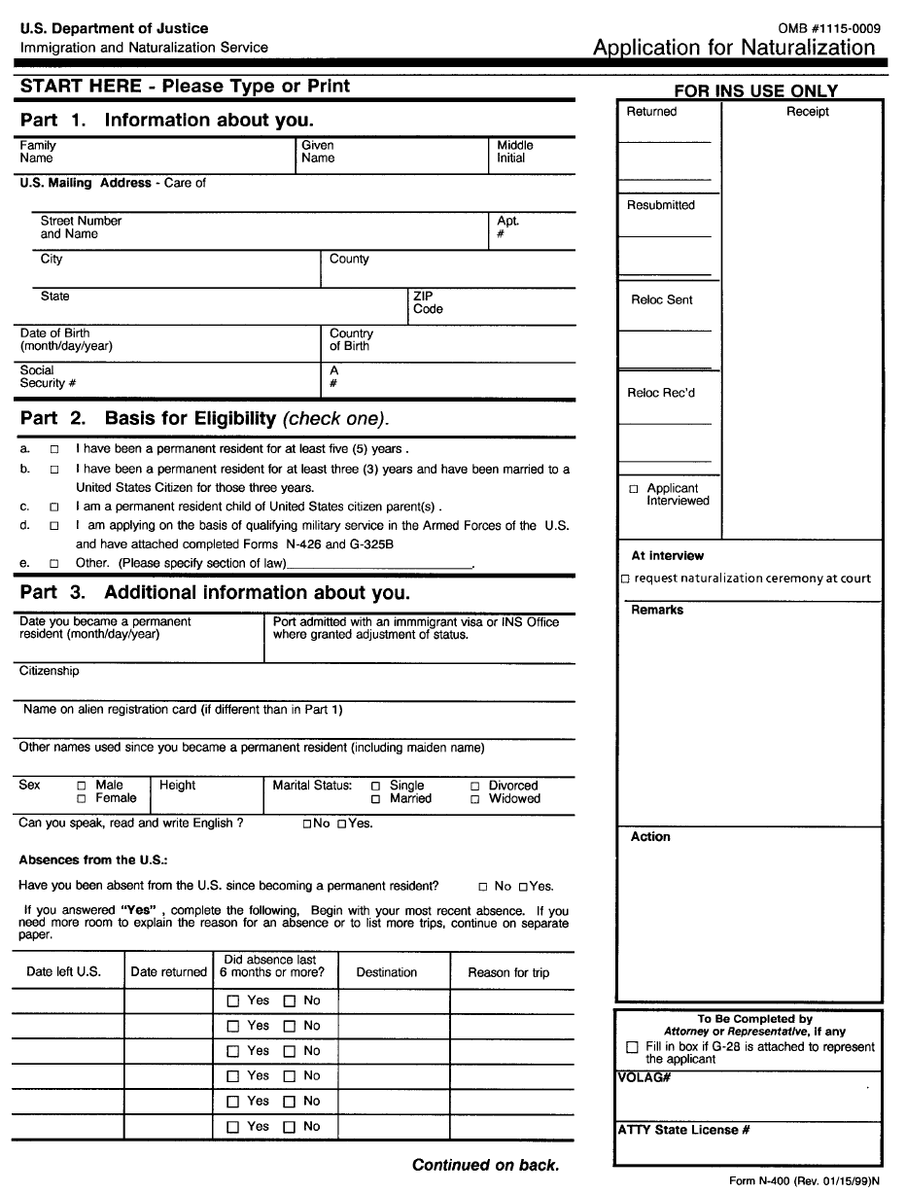
- decide | to choose
- fingerprints | marks in ink made by the lines of the end of your finger | 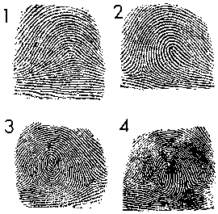
- form | paper that you write information in blank spaces

The Naturalization Process—Things You Have to Do

Vocabulary Page 2

- judge | a person who decides things
- pass | do well
- photo | a picture
- review | to look over something carefully

The Naturalization Process—Things You Have to Do

You have to meet requirements to become a naturalized citizen. There are also things that you have to do.

Some of the things that you have to do are:

- You must fill out a form. The form is called the “Application for Naturalization”. It is also called Form N-400.

- You must pass United States government and history tests.

- You must take a test to show that you can speak and write in English.

- You must have your fingerprints made.

- You must have your photo taken.

- You must go before a judge and ask to be a citizen of the United States. The judge will listen to why you want to be a citizen. He will review everything. He will decide if you can become a U.S. citizen.

- You must take the Oath of Allegiance to the United States.

The Naturalization Process—Things You Have to Do

Vocabulary Matching

Draw a line from the word to the correct definition.

- application | to choose
- form | to look over something carefully
- decide | paper that you write information in blank spaces
- review | marks in ink made by the lines of the end of your finger
- fingerprints | do well
- pass | a picture
- photo | a person who decides things
- judge | a blank form for writing down information

The Naturalization Process—Things You Have to Do
Writing Practice

Write the words.

- application
- decide
- fingerprints
- form
- judge
- pass
- photo
- review

The Naturalization Process—Things You Have to Do
Spelling Practice

Write the correct letter in the blanks.

- deci__e

- jud__e

- __ingerprints

- for__

- ap__lication

- p__oto

- __eview

- pa__s
The Naturalization Process—Things You Have to Do
Circle the Word You Hear

- fingers | fingerprints | Friday
- pass | fast | fail
- book | application | apply
- jury | person | judge
- decide | outside | work
- warm | from | form
- review | view | paper
- please | photo | picture
The Naturalization Process-- Things You Have to Do

Conversation

Student 1 | Hi, what do I have to do to become a naturalized citizen of the United States?
Student 2 | Well, there are several things you have to do.
Student 1 | Can you tell me what to do?
Student 2 | First, you have to fill out an application.
Student 1 | Okay. What else do I have to do?
Student 2 | You have to have your fingerprints made.
Student 1 | Is there anything else that I have to do?
Student 2 | You have to have a your photo made.
Student 1 | I can do that. Is there anything else that I have to do?
Student 2 | Yes, there is a lot to do. You can learn more about this in an ESL class.

The Naturalization Process-- Things You Have to Do
True or False

Circle T if the sentence is true. Circle F if the sentence is false.

T | F | - You do not have to fill out any forms to become a United States citizen.
T | F | - You must pass a United States government and history test to become a United States citizen.
T | F | - You must take a test to show that you can write and speak English to become a United States citizen.
T | F | - You do not have to have a photo taken to become a United States citizen.
T | F | - You must have your fingerprints made to become a United States citizen.
T | F | - You must take an Oath of Allegiance to the United States to become a United States citizen.
T | F | - You do not have to go before a judge to become a United States citizen.
T | F | - The form you must fill out to become a United States citizen is called "Form N-400"

The Naturalization Process-- Things You Have to Do
More Writing Practice

Write each of the following sentences.

1. I want to be a United States citizen.
2. I have to take a reading and writing test.
3. I must take the Oath of Allegiance to become a citizen.
4. My friend had her fingerprints made.
5. My father had his photo taken.

Rights of United States Citizens

Rights of United States Citizens
Vocabulary

- apply | to ask for something in writing
- deported | made to leave the country
- personal reasons | why you do something
- travel | to go from one place to another
- vote | to choose the people in government

Rights of United States Citizens

Some people become citizens because of personal reasons. Other people become citizens because of the rights of being a citizen.

Some of the rights of being a citizen are:

- You can vote.

- You can not be deported.

- You can apply for state and federal jobs that require citizenship.

- You can travel outside of the United States and return more easily.

- You can legally bring family members to live in the United States.

Rights of United States Citizens
Vocabulary Matching

Draw a line from the word to the correct definition.

- vote | to ask for something in writing
- personal reasons | why you do something
- deported | to go from one place to another
- apply | to choose the people in government
- travel | made to leave the country

Rights of United States Citizens
Writing Practice

Write the words.

1. apply
2. deported
3. personal reasons
4. travel
5. vote

Rights of United States Citizens
Spelling Practice

Write the correct letter in the blanks.

- vo_e

- p_rsonal reasons

- _eported

- ap_ly

- trave_

Rights of United States Citizens

Writing Exercise

Why Become a Citizen of the United States?

Write 3 reasons that you would like to be a United States citizen.

1.
2.
3.

Rights of United States Citizens
Circle the Word You Hear

- tired | read | travel
- report | deport | deported
- vote | very | book
- supply | apply | application
- personal | purple | responsible
- try | travel | cake
- red | reasons | ready
- personal reasons | person | seasons
Rights of United States Citizens

Conversation

Student 1 | Hi, why do people become United States citizens?
Student 2 | Some people become citizens for personal reasons.
Student 1 | I want to become a United States citizen because United States citizens have rights.
Student 2 | There are many rights. You can vote and you can not be deported.
Student 1 | What other rights does a U.S. citizen have?
Student 2 | A citizen can apply for federal and state jobs.
Student 1 | That’s good.
Student 2 | Yes, United States citizens have many rights.

Responsibilities of United States Citizens
Responsibilities of United States Citizens
Vocabulary

- believe | to think something is true
- jury | a group of 12 citizens who are asked to sit in a court. They listen to information about a problem or crime. Then they decide who is right.
- respect | to know the importance of something
- responsibilities | more than one responsibility.
- responsibility | something that you should do

Responsibilities of United States Citizens
Vocabulary
Page 2

- taxes | money paid by people to help run the government
- values | things or ideas believed to be important
- worker | a person who works. (Another name for worker is employee.)

Responsibilities of United States Citizens

United States citizens have many rights. They also have responsibilities. A responsibility is something that you should do.

Some of the responsibilities of being a United States citizen are:

- Obey all laws.

- Respect the rights of others.

- Pay taxes.

- Vote.

- Learn about the government.

- Be a member of a jury.

- Be a good worker.

- Be a good family member.

- Get a good education.

- Believe in American values.

Responsibilities of United States Citizens
Vocabulary Matching

Draw a line from the word to the correct definition.

- worker | a group of 12 citizens who are asked to sit in a court. They listen to information about a problem or crime. Then they decide who is right.
- values | a person who works. (Another name for this is employee.)
- taxes | money paid by people to help run the government
- responsibility | more than one responsibility
- responsibilities | to think something is true
- respect | something that you should do
- jury | to know the importance of something
- believe | things or ideas believed to be important
Responsibilities of United States Citizens
Writing Practice

Write the words.

1. believe
2. jury
3. responsibility
4. responsibilities
5. taxes
6. values
7. worker
8. respect

Responsibilities of United States Citizens
Spelling Practice

Write the correct letter in the blanks.

- ta_es

- respon_ibilities

- w_rker

- v_lue

- responsibilit_

- _espect

- _ury

- bel_eve
Responsibilities of United States Citizens
Circle the Word You Hear

- value | book | values
- worker | work | hard
- believe | beliefs | see
- responsibility | responsible | responsibilities
- responsible | respect | respects
- taxes | pay | tax
- responsibilities | responsibility | point
- jury | judge | orange

Responsibilities of United States Citizens

Conversation

Student 1 | Hi, I am going to be a naturalized citizen soon.
Student 2 | Wow! That's great. United States citizens have a lot of rights, don't they?
Student 1 | Yes, but they also have a lot of responsibilities.
Student 2 | What is a responsibility?
Student 1 | A responsibility is something that you should do.
Student 2 | What are some of the responsibilities of United States citizens?
Student 1 | A citizen should obey laws, pay taxes, vote, and learn about the government.
Student 2 | Those are a lot of responsibilities. Are there any other responsibilities?
Student 1 | Yes, there are a lot more.  .
Student 2 | Thanks for telling me about the responsibilities of United States citizens. I have learned a lot!

Responsibilities of United States Citizens
More Writing Practice

Write each of the following sentences.

1. A United States citizen has many responsibilities.
2. A responsibility is something that you should do.
3. Citizens should vote and pay taxes.
4. Citizens should believe in American values.
5. Citizens should obey the laws.

United States Citizenship
Beginning Level
Glossary
United States Citizenship
Beginning Level
Glossary

- allegiance | loyalty
- application | a blank form for writing down information
- apply | to ask for something in writing
- believe | to think something is true
- citizen | a person who is a member of a country
- community | a place where people live and work
- completes | finishes
- country | the land of a group of people united by the same government
- decide | to choose
- deported | made to leave a country
- fingerprints | marks in ink made by the lines of the end of your finger
- form | paper that you write information in blank spaces
- government | the people elected to lead a country, state,  or city
- history | past events of a country or person
- illegal | against the law
- improve | make better
- judge | a person who decides things
- jury | a group of 12 citizens who are asked to sit in a court. They listen to information about a problem or crime. Then they decide who is right.
- law | a rule that you must obey
- loyal | being true to one’s family, friends, or country
- member | a person who belongs to a group
- natural citizen | a person who is born in the United States or whose parents are United States citizens
- naturalization | the process for people who were not born in the United States to become citizens
- naturalization process | the way for people who were not born in the United States to become citizens
- naturalized citizen | a person born in another country who completes the naturalization process
- oath | a promise to do something
- pass | do well
- personal reasons | why YOU do something
- photo | a picture
- process | way
- requirements | things that you have to do
- respect | to know the importance of something
- responsibilities | more than one responsibility
- responsibility | something that you should do
- review | to look over something
- rights | freedoms, liberties, or privileges
- taxes | money paid by people to help run the government
- travel | to go from one place to another
- values | things or ideas believed to be important.
- vote | to choose the people in government
- worker | a person who works; employee

