The United States Capitol

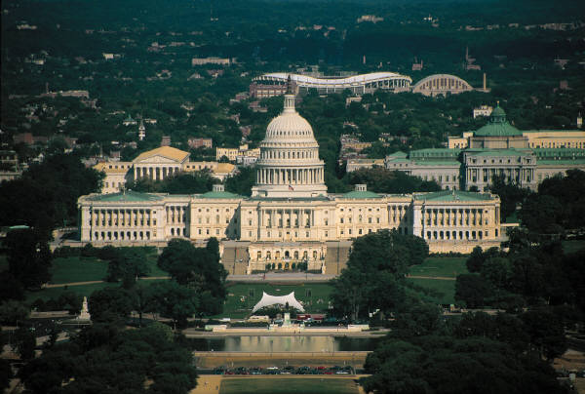

The United States Capitol is a very important building. It is a very large building. It is in Washington, D.C.

The United States Capitol is the home of the House of Representatives and the Senate. This is where our federal laws are made. Federal laws are laws that are made for the whole United States.

United States Capitol Vocabulary

- United States Capitol | the building where our federal laws are made
- important | having great value
- federal laws | laws that are made for the whole United States

