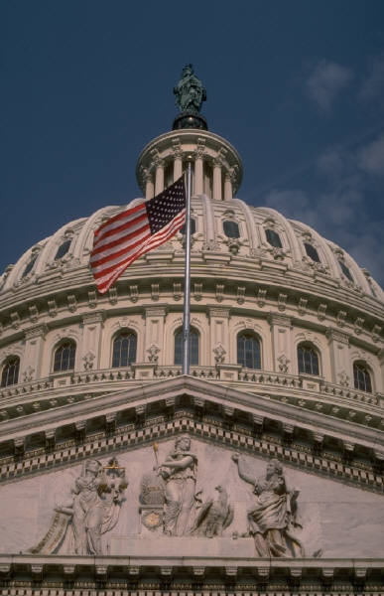

The American flag is flying on top of the United States Capitol.

