Arlington National Cemetery

Vocabulary

- Arlington National Cemetery | A famous military cemetery in the United States.
- cemetery | a place where dead people are buried  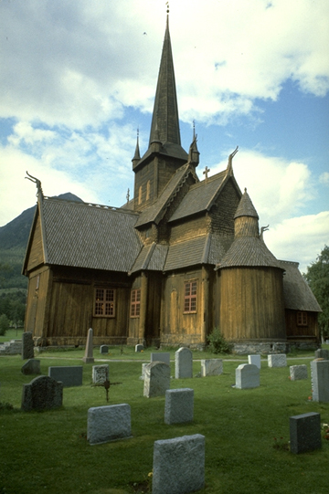
- military |   having to do with the armed forces for the air, land, and sea
- veterans | someone who has been in the military
- buried | to have put a dead body in the ground
- former | past
- armed forces | another name for military

