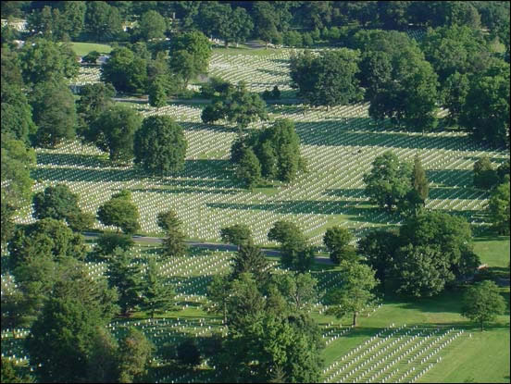
Used with permission from Arlington National Cemetery

