The Flag of the United States of America

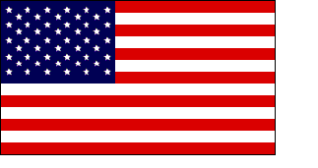

The American flag is a very important symbol of the United States.

The American flag is red, white and blue. The red stands for courage. The white stands for purity. The blue stands for justice.

The American flag has 13 stripes. These stripes represent the 13 original colonies.

The American flag also has 50 stars. These stars represent the 50 states of the United States of America.

Betsy Ross made the first American flag in 1776. The flag that she made looks different than the flag that we have today.

