**Project Title: “A Blast from the Past: Using Computer Analysis to Find a Deadly Microbe”  
Created by Patricia Williams and Shaun Williams, Cleveland Community College**

| **Major Sections** | **Content** |
| --- | --- |
| **Project Overview** | **Overall Purpose/Project Length**   * The purpose of this laboratory is to use data collected from an infectious source and online bioinformatics tools to determine the identity of an infectious microorganism and draw conclusions based on an isolated sequence ID and disease symptoms. * This project should take either two 50 minute class periods or one 2 - 3 hour laboratory class, depending on the length of the course period and the background covered.   **Appropriate Courses for Implementation**   * BIO-111 (General Biology 1) * BIO-275 (Microbiology) * BIO-280 (Biotechnology) * BIO-250 (Genetics) * BTC-270 (Recombinant DNA Techniques) * CIS-110 (Introduction to Computers) * DBA-110 (Database Concepts)   **Key Terms**   * DNA * Gene Structure * Microbe Identification * BLAST Analysis * Bioinformatics * Database Searching * Database Usage * Information Processing   **Student Learning Objectives**  Upon completion of this activity, the student should be able to…   * Describe the structure and function of DNA and explain the genetics relationship between DNA of different organisms. * Identify and differentiate between two different biological species using DNA analysis and bioinformatics. * Discuss the benefits and implications of knowing DNA sequences of humans and other organisms. * Discuss how biotechnology databases are being used in biological research and biological identification. * Explain the use of biotechnology databases in the biological sciences. * Explain how modern bioinformatics tools use computer technology to solve biological problems. * Demonstrate the ability to use computer programs to understand basic biological concepts. |
| **Equipment/Materials** | **List of Materials and Equipment**   * Access to a reliable computer with internet connection (per student or per group). * Student handouts per student or per group (Student Instruction Sheet, Student Data Collection Sheet, and Student Sequence Sheet). * Writing instrument |
| **Discussion** | **Industry/Real-world Scenario**  An archaeologist and his team discover an undisturbed Mayan tomb in the rainforest of Central America. The lead archaeologist is the first member of his team to enter the tomb. Large amounts of dust and decay are suspended in the air after disturbing the tomb. The archaeologist continues into the tomb with no mask or protective gear, other than gloves. After the discovery the archaeologist celebrated with his team, a cigar in one hand and a glass of wine in the other. Days later, the lead archaeologist becomes ill. An illness that began with a simple cough progressively worsened. Eventually, he begins coughing up blood and develops shortness of breath. The researcher is rushed to an emergency room. It is too late and he dies in the hospital. Other members of his team also become ill; some survive and some succumb to the mystery illness. Only members of the team who entered the tomb became ill. The local residents feared an ancient curse placed on the tomb was the reason for the illness and that it had been released on the world. News spread across the world about the tragic deaths of the researchers. Scientists and agents from the Center for Disease Control came to investigate what caused the illnesses. The initial investigations determined that there was an unknown substance covering the walls of the tomb that became airborne when the tomb was disturbed. The CDC sent samples from the tomb to their headquarters in Atlanta, GA, to be sequenced. The CDC determined the illness was caused by something biological in origin. There were three different biological samples identified. Can you search the NCBI database using the found sequences to help the CDC determine what made our researcher sick and die? (Scenario is based loosely on a true story relating to the discovery of Tutankhamun Tomb in Egypt in 1922)  **Proposed Teaching Strategies—going above and beyond lecture and problem sets**   * Teamwork (if working in groups) * Research * Data analysis * Critical thinking |
| **Activities** | **Activity Preparation for Instructor**   1. Either use the sequence provided in instructor resources or copy a gene sequence from the *Aspergillus fumigatus* fungus (if you want to change the sequence from semester-to semester, we recommend copying a random sequence from the fungus each time. If you want to keep the same sequence from semester-to-semester, feel free to use the one we provided in instructor resources (if so... skip steps 1-5 and use the sheet provided).    1. If you choose to change the sequence ...Go to the National Center for Biotechnology Information website: [www.ncbi.nlm.nih.gov](http://www.ncbi.nlm.nih.gov)    2. We need to search through the nucleotide database, not through all the databases, so change from “All Databases” to “Nucleotide”    3. In the search box, enter our fungus, “Aspergillus fumigatus [ORGANISM]”. The "ORGANISM" tag tells the search engine to only look for nucleotide sequences from that specific organism.    4. Select one of the sequences.    5. In the section “ORIGIN” select as many base sequences as you desire (at 10 lines or more).    6. This sequence will be provided to students. 2. Copy a gene sequence from a different fungus or use the same sequence we provide in instructor resources and follow the same steps from above.   Repeat the steps from 1.a. using a different fungus, such as baker’s yeast, *Saccharomyces cerevisiae*   1. Copy a gene sequence from a set of common bacteria or use the same sequence we provide in instructor resources and follow the steps as noted)   Repeat the steps from 1.a. using a common bacteria, such as *Streptococcus pyogenes*   1. If you choose to change the sequences from semester-to-semester, you must ensure that the chosen non-pathogenic fungus and common bacteria **do not** cause the same symptoms after infection. If you use the same sequences provided to you in instructor resources, this has already been taken care of and the sequences are ready for use in the activity.   **Activity Steps**   1. Students need to search through the nucleotide database for the three gene sequences provided.    1. Go to the National Center for Biotechnology Information website: [www.ncbi.nlm.nih.gov](http://www.ncbi.nlm.nih.gov)    2. Click on the “Analyze” area of the page.    3. Select the “Basic Local Alignment Search Tool (BLAST)” Tool.    4. Select the “nucleotide blast” program.    5. Paste the first gene sequence in the box labeled “Enter accession number(s), gi(s), or FASTA sequence(s)”    6. In the “Job Title” box, provide your search with a title, such as “First Sequence”.    7. Ensure that under the “Choose Search Set” area, the “Database” option is set to “Nucleotide collection (nr/nt)”    8. At the bottom of the page, click the “BLAST” button.    9. On the results page, the student should copy down all of the organisms that are listed in the “Sequences producing significant alignments.”    10. Since we know that this is a full sequence for one of the suspect organisms, make sure that "Ident" of the organism is at least 99%.    11. Repeat this for each of the gene sequences. 2. With all of the possible organisms identified, the students need to search through [Microbe Wiki](https://microbewiki.kenyon.edu/index.php/MicrobeWiki). Microbe Wiki is a source to use to help you find information about the specific organisms you identified by using the BLAST search. The students need to record the symptoms of infection by each of the BLAST identified organisms (three were provided). If human infection by one of the BLAST identified organisms is impossible, that also needs to be noted. 3. Comparison can now be made between the symptoms that the archaeologist had with those of each of the BLAST identified organisms. The results of this comparison will lead the student to the culprit in the death of the archaeologist. 4. Use the provided handouts to record and analyze findings.   **Expected Results** (using instructor provided sequences) *Please note that if you choose to find your own sequences, then you may have different results* (Include observations and data collection, calculations, and wrap-up/conclusions).   1. Performing the BLAST searches would yield the following matching organisms:    1. *Aspergillus fumigatus*    2. *Saccharomyces cerevisiae*    3. *Streptococcus pyogenes* 2. Lookup and compile a list of the symptoms of infections and target organs for each of these organisms.    1. *Aspergillus fumigatus*       1. Effected organs: lungs       2. Symptoms: cough, chest pain, breathlessness, etc.    2. *Saccharomyces cerevisiae*       1. Non-pathogenic    3. *Streptococcus pyogenes*       1. Effected organs: skin       2. Symptoms: fever, severe pain, dizziness, and red rash at wound site 3. Comparison with symptoms: *Saccharomyces cerevisiae* is non-pathogenic and can therefore immediately be eliminated. The archaeologist symptoms revolved around the lungs and a lung infection. As such, the culprit for the cause can be narrowed down to *Aspergillus fumigatus*.   **Extension Options**   * This project can be adapted, as suggested in the instructions and instructor resource materials, in order to make the case study applicable to diseases and infections directly affecting the population. (Example – if there is an outbreak of food poisoning in a particular city, the instructor can change the story line and the organisms to directly match an example occurring in their geographic location or area.) |
| **Faculty Resources** | **Background Material**   * Faculty need to become familiar with database searches and how to search through BLAST sequences to find matches to biological organisms. * It is recommended that faculty do a "test-run" before assigning to the class as a project. Due to the nature of research, sequences are being uploaded and updated very frequently and small changes may be needed over time.   **Handouts and Supplemental Materials**   * Student Instruction Sheet * Sequences Sheet (if using sequences provided).   + It is recommended to give the students a digital copy of this handout so they can copy and paste sequences into the database   + If you are changing the sequences, the instructor will need to make their own * Student Data Collection Sheet * Faculty Instruction Sheet   **Answer Keys**   * Faculty Answer Key * Faculty Sequence Information Sheet   **Suggested Website Links (see** **Web Resources Sheet** **for all links)**   * National Center for Biotechnology Information website: [www.ncbi.nlm.nih.gov](http://www.ncbi.nlm.nih.gov) * Centers for Disease Control: [www.cdc.gov](http://www.cdc.gov) * National Institutes of Health: [www.nih.gov](http://www.nih.gov) * MicrobeWiki: <https://microbewiki.kenyon.edu> * [NCBI Glossary](http://www.ncbi.nlm.nih.gov/Class/FieldGuide/glossary.html) - Glossary for the NCBI database to help students learn the various aspects of BLAST searches. * [DNA From the Beginning](http://www.dnaftb.org/15/index.html)  - Website resource with background information on DNA and the basics of gene structure. * [Genetic Science Learning Center](http://learn.genetics.utah.edu/) – Website resource with background on Genetics. * [DNAi](http://www.dnai.org/a/index.html) – Website resource for basics on DNA and genetic structure. * [NIH BLAST Check for Understanding](https://www.genome.gov/25020002/online-education-kit-bioinformatics-finding-functions/) – Link to background information on BLAST searches with a check for understanding. * [NIH BLAST Tutorials](https://www.youtube.com/playlist?list=PLH-TjWpFfWrtjzMCIvUe-YbrlIeFQlKMq) – A faculty resource to bring you up to speed on BLAST Techniques. |
| **Assessment** | **How will students demonstrate what they have learned?**   * Students will be evaluated on the final submission of the assignment. Correct identification of the causative organism will determine mastery on the concepts being evaluated.   **Assessment Tools**   * Performance task checklist |

**A Blast from the Past: Using Computer Analysis to Find a Deadly Microbe**

**Student Instruction Sheet**

**Introduction:**

An archaeologist and his team discover an undisturbed Mayan tomb in the rainforest of Central America. The lead archaeologist is the first member of his team to enter the tomb. Large amounts of dust and decay are suspended in the air after disturbing the tomb. The archaeologist continues into the tomb with no mask or protective gear, other than gloves. After, the discovery, the archaeologist celebrated the discovery with his team, a cigar in one hand and a glass of wine in the other. Days later, the lead archaeologist becomes ill. An illness that began with a simple cough progressively worsened. Eventually, the lead archaeologist begins coughing up blood, and develops shortness of breath. The researcher is rushed to an emergency room. It is too late for the researcher and he dies in the hospital. Other members of his team also get ill, some survive and some succumb to the mystery illness. Only members of team who entered the tomb became ill. The local residents feared an ancient curse placed on the tomb was the reason for the illness and that it had been released on the world. News spread across the world about the tragic deaths of the researchers. Scientists and agents from the Center for Disease Control came to investigate what caused the illnesses. The initial investigations determined that there was an unknown substance covering the walls of the tomb that became airborne when the tomb was disturbed. The CDC sent samples from the tomb to their headquarters in Atlanta, GA to be sequenced. The CDC determined the illness was caused by something biological in origin. There were three different biological samples identified. Can you search the NCBI database using the found sequences to help the CDC determine what made our researcher sick and die? (Scenario is based loosely on a true story relating to the discovery of Tutankhamun Tomb in Egypt in 1922)

**Activity 1: Identifying the Unknown Sequences**

In order to identify the unknown sequences found by the Centers for Disease Control, we must use a computer program housed by the National Institutes of Health. It is called the National Center for Biotechnology Information (NCBI) and a tool called BLAST.  BLAST (Basic Local Alignment Search Tool) searching is a key bioinformatic tool for sequence comparison and genome database searching. The program identifies sequences in a database that are similar to the entered query sequence, and ranks them based on the length and quality of the alignment. You have been provided with short segments that were isolated from the researcher in the story above. It is your task to use this computer program to identify the three organisms isolated from the researcher.

**Step 1:** Go to the National Center for Biotechnology Information website: [www.ncbi.nlm.nih.gov](http://www.ncbi.nlm.nih.gov).

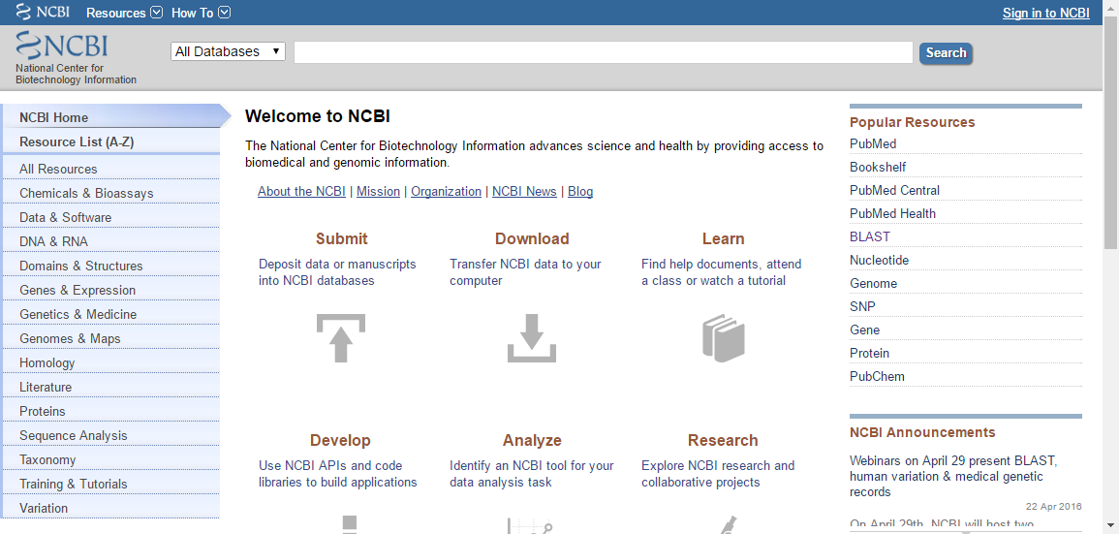

Figure : NCBI Database Website

* Click on the “Analyze” area of the page.

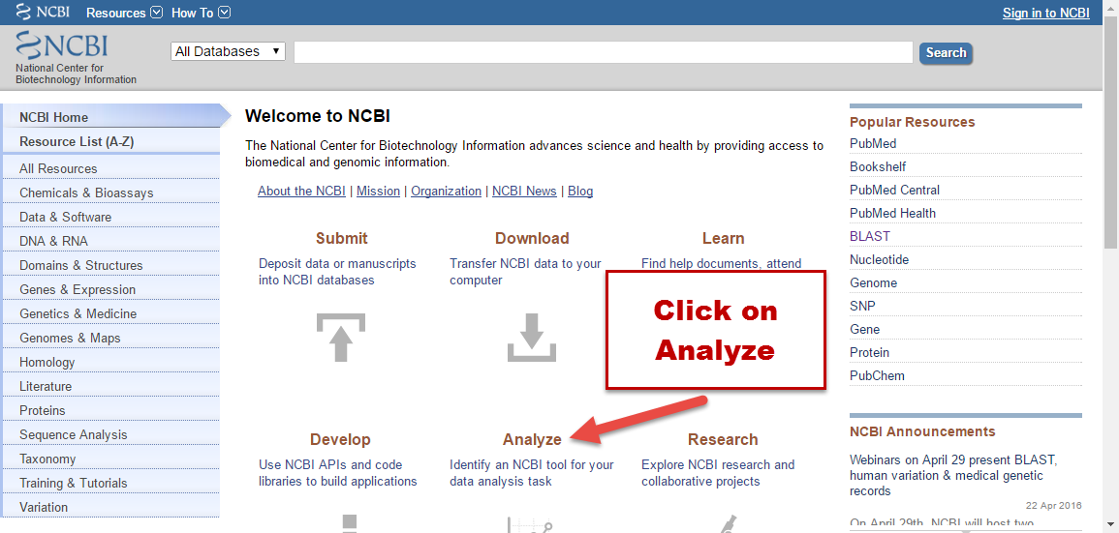

Figure : Click on Analyze

* Select the “Basic Local Alignment Search Tool (BLAST)” Tool.

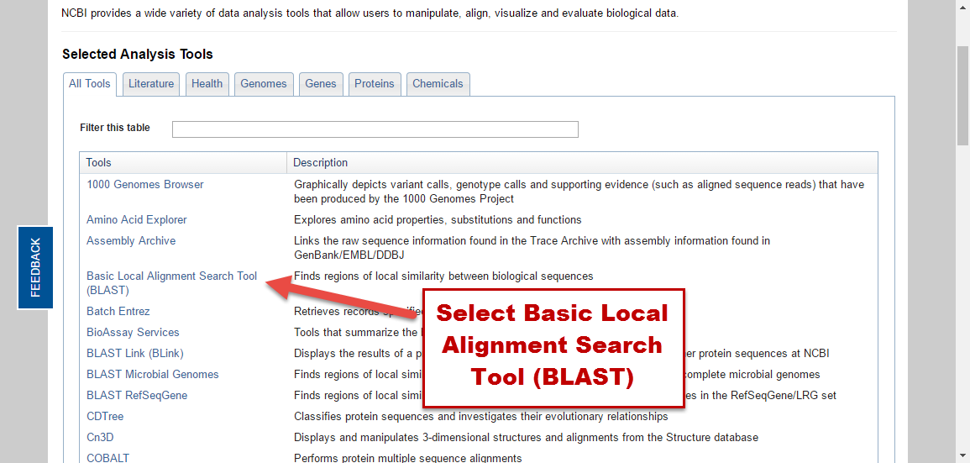

Figure : Select the BLAST tool

* Select the “nucleotide blast” program.

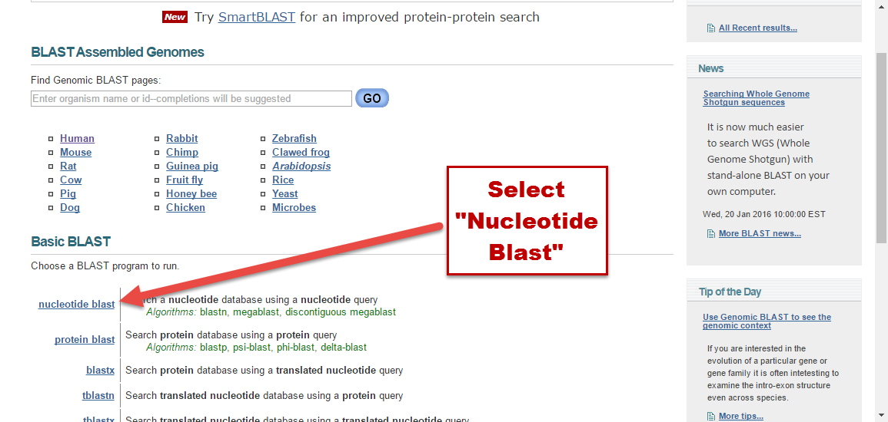

Figure : Select Nucleotide Blast

**Step 2:** Paste the first gene sequence in the box labeled “Enter accession number(s), gi(s), or FASTA sequence(s)”

* In the “Job Title” box, provide your search with a title, such as “First Sequence”.
* Ensure that under the “Choose Search Set” area, the “Database” option is set to “Nucleotide collection (nr/nt)”

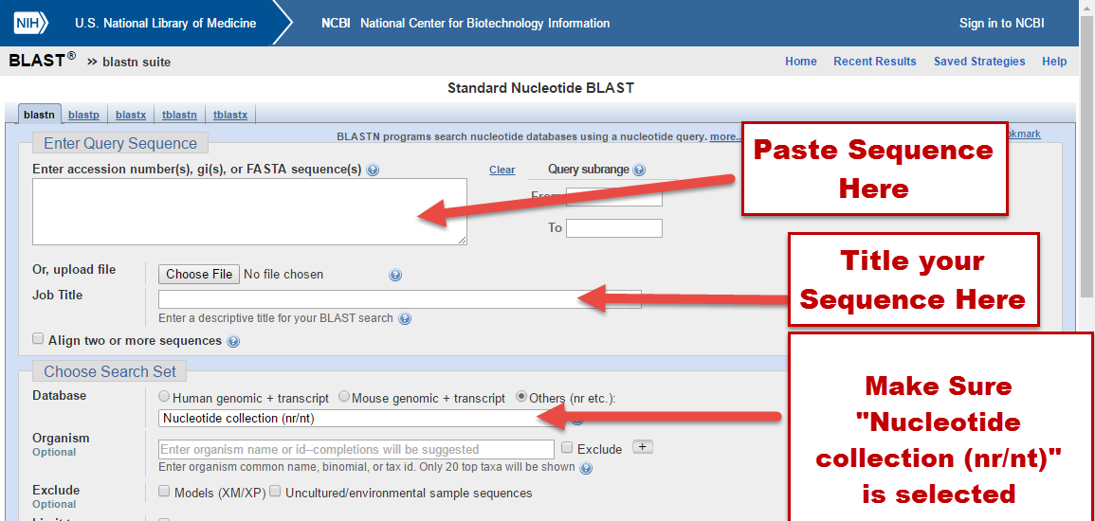

Figure : BLAST Search for Unknown Organism

* At the bottom of the page, click the “BLAST” button.

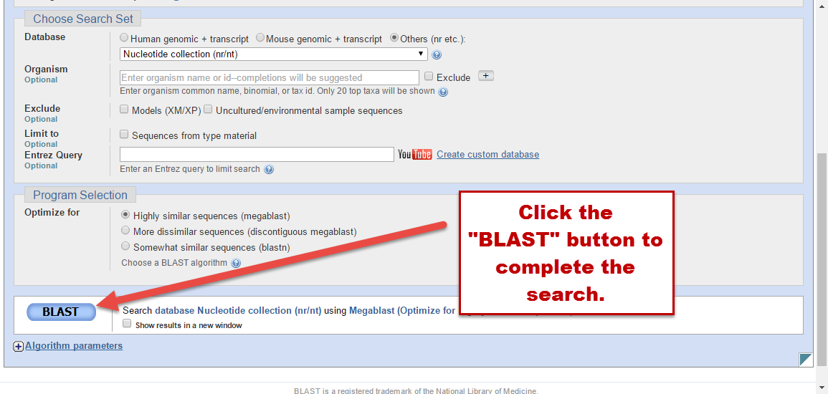

Figure : Click BLAST

**Step 3:** On the results page (the handout titled “Student Data Collection Sheet,” copy down all of the organisms that are listed in the “Sequences producing significant alignments.”

* Since we know that this is a full sequence for one of the suspect organisms, make sure that "Ident" of the organism is at least 99%.

**Step 4:** Repeat Steps 1-3 for each of the gene sequences.

* Make sure to follow each step exactly and to double check your inquiries before each run.
* Also, make sure you properly label each sequence so you know which of the unknown sequences belong to each search.

**Activity 2: Classifying the Identified Sequences and Determining the Causative Agent**

**Step 1:** With all of the possible organisms identified, navigate to [Microbe Wiki](https://microbewiki.kenyon.edu/index.php/MicrobeWiki).

* Microbe Wiki is a source to help you find information about the specific organisms you identified by using the BLAST search.
* Record the symptoms of infection by each of the BLAST identified organisms (three were provided).
* If human infection by one of the BLAST identified organisms is impossible, that also needs to be noted.
* Make sure to complete a search for each organism uncovered by the BLAST analysis of your three unknown organisms.

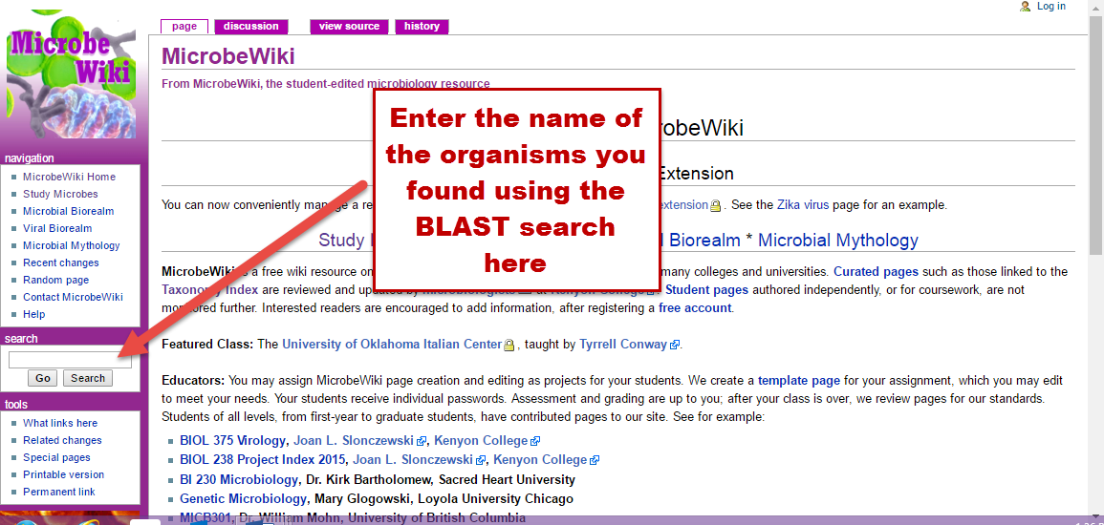

Figure : Microbe Wiki

**Step 2:** Comparison can now be made between the symptoms that the archaeologist had with those of each of the BLAST identified organisms.

* The results of this comparison will lead the student to the culprit in the death of the archaeologist.
* Document your information on the provided “Student Data Collection Sheet”.

**Step 3:** Answer the questions on the “Student Data Collection Sheet” and write your final conclusion on the organism that caused the death of the researcher.

**“A Blast from the Past: Using Computer Analysis to Find a Deadly Microbe”**

**Sequence Sheet**

Directions: Use the following sequences to help you identify the unknown organism that caused the death of the researcher. Only one of these sequences belongs to the organism that killed the researcher. It is up to you to identify each of these organisms that were found by the CDC to determine which one is the causative agent. *** See the student instruction sheet for step-by-step guidance. ***

**Unknown Organism #1:**

gcatgcacta tctggctctc cgacggtgtg cgatgcagag ttgcaatgtt accctgttag ttcccactgc attctccgga tcactttccg gattgtctcc atccttgtct cgcggtggtg actaggagat tctgaggcat gaaaatggca caagtgctga agaacatgaa tggaacacga agagacaaaa agttataaat acctgcctgt cctccagaga tctgtgtcca ccagaccatt cagtccaaca tctcccagcc tgatccggca tctaaagtct tgtcagagtc tgcgccatgc tttctatcaa acgcactttg ctgctccttg gagctgtcct gccagccgtc tttggcgcgc ctgtccagga aactcgtcgt gctgctcaga agattcctgg caagtacatc gtgaccttca agccgggcac cgatacagct accattgagt ctcacactct ttgggccact gatcttcaca aacgcaatct ggagcgtcgt gataccacta gcggcgaacc tcccgtcggt atcgagaaga gctacaagat caaggatttc gccgcctacg ctggctcctt cgatgacgcc accatcgagg aaatccgcaa gaggggagac gtcagtactc ttcagaaccc cagcacataa taggacaagt ggcttacaag tgcacaggtt gcccatgttg aggaggacca aatctggtac cttgacgcct tgaccactca aaagggcgcc ccatggggcc tgggcagcat ttcccacaag ggacaagcaa gcaccgacta catctacgac accagcgctg gcgcaggcac ctatgcctac gttgtcgaca gtggcatcaa tgtcaaccac gtcgagttcg agagccgcgc atcgctggca tacaacgccg ctggtggcag ccatgttgac agcatcggcc acggaacgca cgttgctggt accattggcg gcaagaccta cggagtggcc aagaagacca accttctgtc cgtcaaggtc ttccagggcg

**Unknown Organism #2:**

gtcgacaaaa atatacggaa gaaatggaca aggcgattaa tctactgaaa acaaatataa agaaggagta tagacatgat aagtatttgg agcggacaaa ggtaggaacg tatcctggta gaagaacata tcctggtagg agaacatatc ccgctaggag aacatatccc gctagcagaa catattcaga tagcaattca tacacttttc ggataaatgt ccagaagatt aggcacgcat tagtacgtta caatcaagat ggtgttcaaa aacacaacca aaagcctcct aggattggtc atggattaac gagagtgtta taccaaccgt tgtcgctaca aaaattgaga gataatagga gcagaatgta taattttgac cctgcagtgg aaaatattaa tccagagtat ttggaaaaga aaagtgaaaa agatgtgaac acagactcct ctggagaagg acaaagcaag ccaatattca tcacacccca caaagatgaa tctctgttaa aggttgccaa agaacataga aaaaagtaca tatcttcatc aagttccatg acatcagtac tttctcagtt gcactattta ttatccaatt tcagaagatt gaatatcatt gattcctcga tatcgaaaaa ttttcctcaa aaaaactgca attattcaga aagtgcatat tttccgtcag cagtcattct gagaaagaag agaaatggca tttgttctat tgattcagat agaagtctgg atagggagat tgtgctttct gtactaggtc attatcttga agacttttta acggaaaagt ccctgaagaa tagttcaaaa agtgaaaatt atcactattc tagtatagat gaattcattg tgagatctca attggacgcg tacgacccaa atctacctgg aacgggtgta tttgatctga agacaagagc agtttctgcc ataagatacg atttatcaca tgtagagagt aataacaacc aaactggata tgagatagat aaagtttatg

**Unknown Organism #3:**

cctggtcttt accttttacc gctcattctt tagaatagaa ttattagaga gaagtcttag aaaaatgagg ctaattccct aaaagatgaa aaaaataagg agcaaataat ggctagaaaa gatacgaata aacagtattc gcttagaaaa ttaaaaacag gtacagcatc agtagcggtc gctgtggctg ttttaggagc aggctttgca aaccaaacag aagttaaggc tgcggagatt aaaaagcctc aggctgattc agcgtggaac tggcctaaag aatataacgc gttacttaag gaaaatgagg agctcaaggt agaacgtgaa aaatatctat cttatgctga cgataaagaa aaagatcctc aatatagagc attaatgggt gaaaatcaag atcttcgaaa aagagaggga caatatcagg acaaaataga agaacttgaa aaagaaagaa aagaaaaaca agaaagacaa gaacaattag aacgtcaata tcaaatagaa gcagataagc attatcaaga acaacaaaag aaacatcagc aagaacaaca acaattagaa gcagaaaaac aaaaattagc taaagacaaa caaatctcag acgcaagccg tcaaggccta agccgtgacc ttgaagcgtc tcgtgcagct aaaaaagagc ttgaagctga gcaccaaaaa ctcaaagagg aaaaacaaat ctcagacgca agccgtcaag gtctaagccg tgaccttgaa gcgtctcgcg aagctaagaa aaaagtagaa gcagacctag ctgctcttac tgctgagcac caaaaactca aagaggacaa acaaatctca gacgcaagcc gtcaaggcct aagccgtgac cttgaagcgt ctcgcgaagc taagaaaaaa gtagaagcag acttagcaga agcaaatagc aaacttcaag cccttgaaaa actaaacaaa gagcttgaag aaggtaagaa attatcagaa aaagaaaaag ctgagttaca agcaagacta

**“A Blast from the Past: Using Computer Analysis to Find a Deadly Microbe”**

**Student Data Collection Sheet**

**Activity 1: Identifying Unknown Sequences**

1. **Unknown Sequence #1 –** 
   1. The BLAST search identified the organism as _____________________________.
   2. How many results were reported at a 99% or higher similarity? ___________. Were they of the same organism? __________. If not, what were they identified as? ______________________________________________________________.
2. **Unknown Sequence #2 –** 
   1. The BLAST search identified the organism as _____________________________.
   2. How many results were reported at a 99% or higher similarity? ___________. Were they of the same organism? __________. If not, what were they identified as? ______________________________________________________________.
3. **Unknown Sequence #3 –** 
   1. The BLAST search identified the organism as _____________________________.
   2. How many results were reported at a 99% or higher similarity? ___________. Were they of the same organism? __________. If not, what were they identified as? ______________________________________________________________.
4. **What did you find challenging about using the NCBI database?** ________________________________________________________________________________________________________________________________________________________________________________________________________________________________________________________________________________________________
5. **Describe how the BLAST search and the NCBI database can be useful in other areas of research.** ________________________________________________________________________________________________________________________________________________________________________________________________________________________________________________________________________________________________

**Activity 2: Classifying the Identified Sequences and Determining the Causative Agent** (Use information gathered from Microbe Wiki to obtain you information)

1. **What is the name of Unknown Organism #1?** __________________________________.
   1. Is the organism pathogenic? _________________________.
   2. Is the organism bacterial, fungal, or viral? _______________________________.
   3. What organs, if any, does the organism affect? ___________________________.
   4. What are the symptoms a person can experience, if any, if infected? ____________________________________________________________________________________________________________________________________
2. **What is the name of Unknown Organism #2?** __________________________________.
   1. Is the organism pathogenic? _________________________.
   2. Is the organism bacterial, fungal, or viral? _______________________________.
   3. What organs, if any, does the organism affect? ___________________________.
   4. What are the symptoms a person can experience, if any, if infected? ____________________________________________________________________________________________________________________________________
3. **What is the name of Unknown Organism #3?** __________________________________.
   1. Is the organism pathogenic? _________________________.
   2. Is the organism bacterial, fungal, or viral? _______________________________.
   3. What organs, if any, does the organism affect? ___________________________.
   4. What are the symptoms a person can experience, if any, if infected? ____________________________________________________________________________________________________________________________________
4. **What organism is the cause of the archaeologist’s death from the story?** ________________________________________________________________________
5. **Explain your reasoning** ________________________________________________________________________________________________________________________________________________________________________________________________________________________________________________________________________________________________________________________________________________________________________

**A Blast from the Past: Using Computer Analysis to Find a Deadly Microbe**

**Faculty Instruction Sheet**

**Introduction:**

An archaeologist and his team discover an undisturbed Mayan tomb in the rainforest of Central America. The lead archaeologist is the first member of his team to enter the tomb. Large amounts of dust and decay are suspended in the air after disturbing the tomb. The archaeologist continues into the tomb with no mask or protective gear, other than gloves. After, the discovery, the archaeologist celebrated the discovery with his team, a cigar in one hand and a glass of wine in the other. Days later, the lead archaeologist becomes ill. An illness that began with a simple cough progressively worsened. Eventually, the lead archaeologist begins coughing up blood, and develops shortness of breath. The researcher is rushed to an emergency room. It is too late for the researcher and he dies in the hospital. Other members of his team also get ill, some survive and some succumb to the mystery illness. Only members of team who entered the tomb became ill. The local residents feared an ancient curse placed on the tomb was the reason for the illness and that it had been released on the world. News spread across the world about the tragic deaths of the researchers. Scientists and agents from the Center for Disease Control came to investigate what caused the illnesses. The initial investigations determined that there was an unknown substance covering the walls of the tomb that became airborne when the tomb was disturbed. The CDC sent samples from the tomb to their headquarters in Atlanta, GA to be sequenced. The CDC determined the illness was caused by something biological in origin. There were three different biological samples identified. Can you search the NCBI database using the found sequences to help the CDC determine what made our researcher sick and die? (Scenario is based loosely on a true story relating to the discovery of Tutankhamun Tomb in Egypt in 1922)

**Preparing the Gene Sequences**

Gene sequences need to be identified for each of the culprit species, *Aspergillus fumigatus*, as well as a different fungus, such as *Saccharomyces cerevisiae*, and a bacteria species, such as *Streptococcus pyogenes*. If you chose to alter the identity of the second fungus species or of the bacteria species, check their symptoms out using MicrobeWiki (<https://microbewiki.kenyon.edu/>) to ensure that their symptoms do not overlap with that of the desired culprit, *Aspergillus fumigatus*.

In order to get the gene sequence:

1. Go to National Center for Biotechnology Information website (<http://www.ncbi.nlm.nih.gov/> )
2. At the top of the screen, set the search type to Nucleotide and enter your species name followed by [ORGANISM] as shown in the following screenshot.

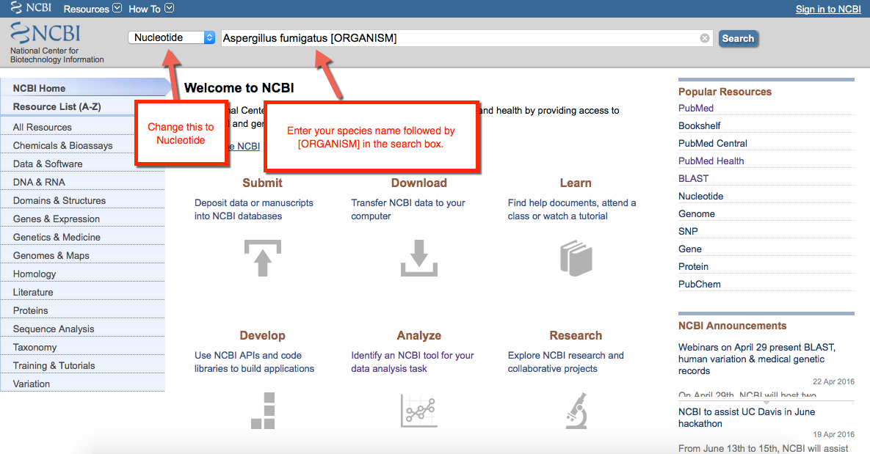

1. On the screen, look for a result that contains at least 1020 base pairs (1020 bp) as shown in the following image. Select the link directly above it to enter that item in the database.

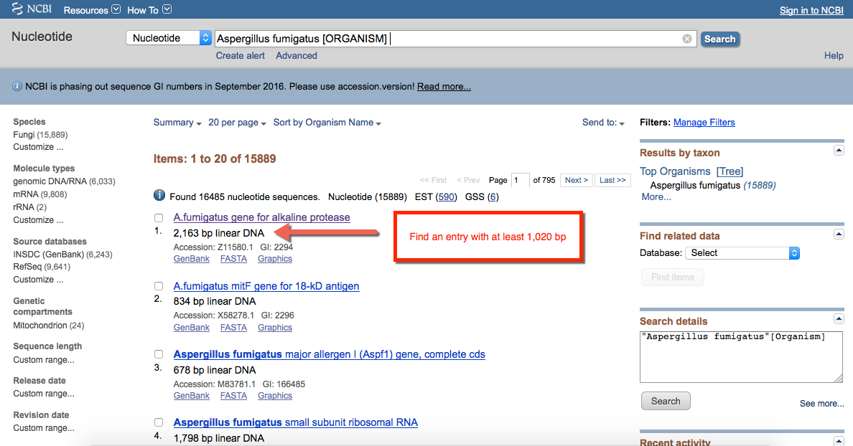

1. Near the bottom of the resulting database item entry is a section entitled “ORIGIN” (see the following figure). This is the gene sequence. Select and copy at least 1020 base pairs from this entry (boxed in the following image).

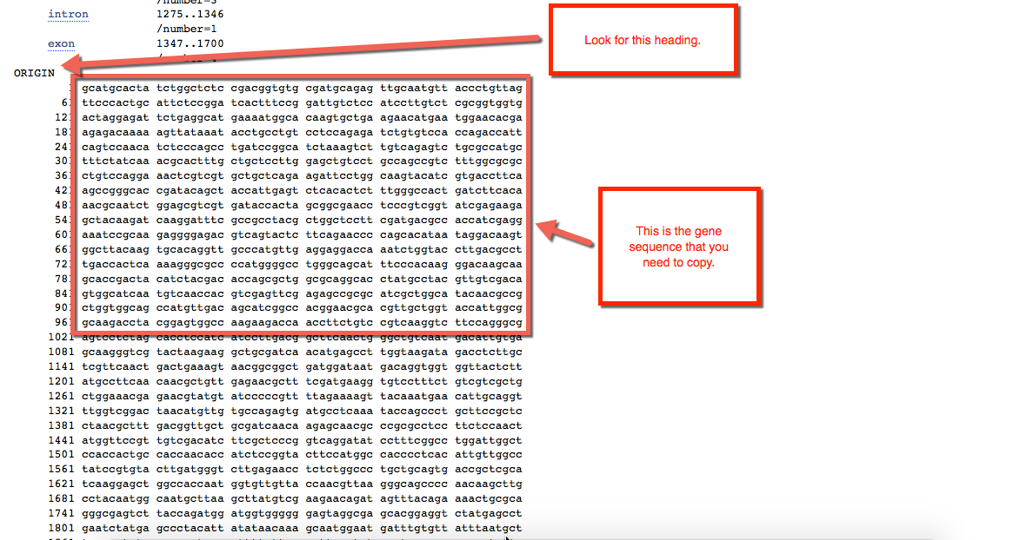

1. Paste this sequence into the student documents.
2. Repeat this procedure for the other two microbe species.

**Perform the analysis as the students would**

In order to ensure that the students will get the correct results, you need to perform the entire BLAST analysis using the gene sequences that you have extracted from the database.

**Activity 1: Identifying the Unknown Sequences**

In order to identify the unknown sequences found by the Centers for Disease Control, we must use a computer program housed by the National Institutes of Health. It is called the National Center for Biotechnology Information (NCBI) and a tool called BLAST.  BLAST (Basic Local Alignment Search Tool) searching is a key bioinformatic tool for sequence comparison and genome database searching. The program identifies sequences in a database that are similar to the entered query sequence, and ranks them based on the length and quality of the alignment. You have been provided with short segments that were isolated from the researcher in the story above. It is your task to use this computer program to identify the three organisms isolated from the researcher.

**Step 1:** Go to the National Center for Biotechnology Information website: [www.ncbi.nlm.nih.gov](http://www.ncbi.nlm.nih.gov).



Figure : NCBI Database Website

* Click on the “Analyze” area on the page.



Figure : Click on Analyze

* Select the “Basic Local Alignment Search Tool (BLAST)” Tool.



Figure : Select the BLAST tool

* Select the “nucleotide blast” program.



Figure : Select Nucleotide Blast

**Step 2:** Paste the first gene sequence in the box labeled “Enter accession number(s), gi(s), or FASTA sequence(s)”

* In the “Job Title” box, provide your search with a title, such as “First Sequence”.
* Ensure that under the “Choose Search Set” area, the “Database” option is set to “Nucleotide collection (nr/nt)”



Figure : BLAST Search for Unknown Organism

* At the bottom of the page, click the “BLAST” button.



Figure : Click BLAST

**Step 3:** On the results page (the handout titled “Student Data Collection Sheet”), copy down all of the organisms that are listed in the “Sequences producing significant alignments”

* Since we know that this is a full sequence for one of the suspect organisms, make sure that "Ident" of the organism is at least 99%.

**Step 4:** Repeat Steps 1-3 for each of the gene sequences.

* Make sure to follow each step exactly and to double check your inquiries before each run.
* Also, make sure you properly label each sequence so you know which of the unknown sequences belong to each search.

**Activity 2: Classifying the Identified Sequences and Determining the Causative Agent**

**Step 1:** With all of the possible organisms identified, navigate to [Microbe Wiki](https://microbewiki.kenyon.edu/index.php/MicrobeWiki).

* Microbe Wiki is a source to use to help you find information about the specific organisms you identified by using the BLAST search.
* Record the symptoms of infection by each of the BLAST identified organisms (three were provided).
* If human infection by one of the BLAST identified organisms is impossible, that also needs to be noted.
* Make sure to complete a search for each organism uncovered by the BLAST analysis of your 3 unknown organisms.



Figure : Microbe Wiki

**Step 2:** Comparison can now be made between the symptoms that the archaeologist had with those of each of the BLAST identified organisms.

* The results of this comparison will lead the student to the culprit in the death of the archaeologist.
* Document your information on the provided “Student Data Collection Sheet”.

**Step 3:** Answer the questions on the “Student Data Collection Sheet” and write your final conclusion on the organism that caused the death of the researcher.

Now that you have completed the lab from the perspective of the student, make sure that the sequences that you provided yield the correct answers to the student questions. If not, you need to go back and get new gene sequences. Additionally, if too many organisms are identified by BLAST, copy a longer gene sequence. For instance, instead of selecting a 1020 base pair sequence to give to the students, increase it to 1500 bp or more.

**Steps for Day of Instruction:**

**Step 1: Provide students the appropriate handouts**

* **Student Instruction Sheet** (one per person or group)
* **Student Sequence Sheet** – it is advised to provide the students a digital copy of this sheet to allow the students to copy and paste the sequence into the database as opposed to typing the individual base pairs. (one per person or group)
* **Student Data Collection Sheet** (one per person or group)

**Step 2: Ensure students have access to the internet and the appropriate sites.**

* Although it is provided in the handouts, make sure to discuss the websites the students will be accessing and ensure that they understand why they are using each site.

**Step 3: Monitor student progress throughout the assignment.**

* Students will be new to using this type of database information. Make sure to walk around and help the students read the output from the BLAST search.
* Students may have questions understanding why there are multiple results of the same species in the results section.

**Step 4: Collect and Grade Student Responses**

* Students should record responses on the **Data Collection Sheet**
* Use the **Grading Check Sheet** to grade the student responses. The check sheet has a section for each question the students answered. The check sheet is scored out of 100 points. A **faculty answer key** has also been provided.

**“A Blast from the Past: Using Computer Analysis to Find a Deadly Microbe”**

**Faculty Sequence Sheet**

This is the answer key for the Student Sequence Sheet. This sheet should not be provided to the student.

**Unknown Organism #1:** *Aspergillus fumigatus*

gcatgcacta tctggctctc cgacggtgtg cgatgcagag ttgcaatgtt accctgttag ttcccactgc attctccgga tcactttccg gattgtctcc atccttgtct cgcggtggtg actaggagat tctgaggcat gaaaatggca caagtgctga agaacatgaa tggaacacga agagacaaaa agttataaat acctgcctgt cctccagaga tctgtgtcca ccagaccatt cagtccaaca tctcccagcc tgatccggca tctaaagtct tgtcagagtc tgcgccatgc tttctatcaa acgcactttg ctgctccttg gagctgtcct gccagccgtc tttggcgcgc ctgtccagga aactcgtcgt gctgctcaga agattcctgg caagtacatc gtgaccttca agccgggcac cgatacagct accattgagt ctcacactct ttgggccact gatcttcaca aacgcaatct ggagcgtcgt gataccacta gcggcgaacc tcccgtcggt atcgagaaga gctacaagat caaggatttc gccgcctacg ctggctcctt cgatgacgcc accatcgagg aaatccgcaa gaggggagac gtcagtactc ttcagaaccc cagcacataa taggacaagt ggcttacaag tgcacaggtt gcccatgttg aggaggacca aatctggtac cttgacgcct tgaccactca aaagggcgcc ccatggggcc tgggcagcat ttcccacaag ggacaagcaa gcaccgacta catctacgac accagcgctg gcgcaggcac ctatgcctac gttgtcgaca gtggcatcaa tgtcaaccac gtcgagttcg agagccgcgc atcgctggca tacaacgccg ctggtggcag ccatgttgac agcatcggcc acggaacgca cgttgctggt accattggcg gcaagaccta cggagtggcc aagaagacca accttctgtc cgtcaaggtc ttccagggcg

* Is the organism pathogenic? *Yes*
* Is the organism bacterial, fungal, or viral? *Fungal*
* What organs, if any, does this organism infect? *Lungs*
* What are the symptoms a person can experience if infected? *Cough, chest pain, breathlessness, severe cases even death*

**Unknown Organism #2:** *Saccharomyces cerevisiae*

gtcgacaaaa atatacggaa gaaatggaca aggcgattaa tctactgaaa acaaatataa agaaggagta tagacatgat aagtatttgg agcggacaaa ggtaggaacg tatcctggta gaagaacata tcctggtagg agaacatatc ccgctaggag aacatatccc gctagcagaa catattcaga tagcaattca tacacttttc ggataaatgt ccagaagatt aggcacgcat tagtacgtta caatcaagat ggtgttcaaa aacacaacca aaagcctcct aggattggtc atggattaac gagagtgtta taccaaccgt tgtcgctaca aaaattgaga gataatagga gcagaatgta taattttgac cctgcagtgg aaaatattaa tccagagtat ttggaaaaga aaagtgaaaa agatgtgaac acagactcct ctggagaagg acaaagcaag ccaatattca tcacacccca caaagatgaa tctctgttaa aggttgccaa agaacataga aaaaagtaca tatcttcatc aagttccatg acatcagtac tttctcagtt gcactattta ttatccaatt tcagaagatt gaatatcatt gattcctcga tatcgaaaaa ttttcctcaa aaaaactgca attattcaga aagtgcatat tttccgtcag cagtcattct gagaaagaag agaaatggca tttgttctat tgattcagat agaagtctgg atagggagat tgtgctttct gtactaggtc attatcttga agacttttta acggaaaagt ccctgaagaa tagttcaaaa agtgaaaatt atcactattc tagtatagat gaattcattg tgagatctca attggacgcg tacgacccaa atctacctgg aacgggtgta tttgatctga agacaagagc agtttctgcc ataagatacg atttatcaca tgtagagagt aataacaacc aaactggata tgagatagat aaagtttatg

* Is the organism pathogenic? *No – non pathogenic*
* Is the organism bacterial, fungal, or viral***?*** *Fungal*
* What organs, if any, does this organism infect? *None*
* What are the symptoms a person can experience if infected? *None*

**Unknown Organism #3:** *Streptococcus pyogenes*

cctggtcttt accttttacc gctcattctt tagaatagaa ttattagaga gaagtcttag aaaaatgagg ctaattccct aaaagatgaa aaaaataagg agcaaataat ggctagaaaa gatacgaata aacagtattc gcttagaaaa ttaaaaacag gtacagcatc agtagcggtc gctgtggctg ttttaggagc aggctttgca aaccaaacag aagttaaggc tgcggagatt aaaaagcctc aggctgattc agcgtggaac tggcctaaag aatataacgc gttacttaag gaaaatgagg agctcaaggt agaacgtgaa aaatatctat cttatgctga cgataaagaa aaagatcctc aatatagagc attaatgggt gaaaatcaag atcttcgaaa aagagaggga caatatcagg acaaaataga agaacttgaa aaagaaagaa aagaaaaaca agaaagacaa gaacaattag aacgtcaata tcaaatagaa gcagataagc attatcaaga acaacaaaag aaacatcagc aagaacaaca acaattagaa gcagaaaaac aaaaattagc taaagacaaa caaatctcag acgcaagccg tcaaggccta agccgtgacc ttgaagcgtc tcgtgcagct aaaaaagagc ttgaagctga gcaccaaaaa ctcaaagagg aaaaacaaat ctcagacgca agccgtcaag gtctaagccg tgaccttgaa gcgtctcgcg aagctaagaa aaaagtagaa gcagacctag ctgctcttac tgctgagcac caaaaactca aagaggacaa acaaatctca gacgcaagcc gtcaaggcct aagccgtgac cttgaagcgt ctcgcgaagc taagaaaaaa gtagaagcag acttagcaga agcaaatagc aaacttcaag cccttgaaaa actaaacaaa gagcttgaag aaggtaagaa attatcagaa aaagaaaaag ctgagttaca agcaagacta

* Is the organism pathogenic? *Yes*
* Is the organism bacterial, fungal, or viral? *Bacterial*
* What organs, if any, does this organism infect? *Skin and other areas*
* What are the symptoms a person can experience if infected? F*ever, severe pain, dizziness, and red rash at wound site*

**“A Blast from the Past: Using Computer Analysis to Find a Deadly Microbe”**

**Faculty Answer Key for**

**Student Data Collection Sheet**

**Activity 1: Identifying Unknown Sequences**

1. **Unknown Sequence #1 –** 
   1. The BLAST search identified the organism as ***Aspergillus fumigatu*** .
   2. How many results were reported at a 99% or higher similarity? **3**. Were they of the same organism?   **YES**. If not, what were they identified as? **All were the same organism**
2. **Unknown Sequence #2 –**
   1. The BLAST search identified the organism as ***Saccharomyces cerevisiae***.
   2. How many results were reported at a 99% or higher similarity? **> than 50**. Were they of the same organism?   **YES** . If not, what were they identified as?   **All were the same organism**
3. **Unknown Sequence #3 –** 
   1. The BLAST search identified the organism as ***Streptococcus pyogenes***  .
   2. How many results were reported at a 99% or higher similarity?   **2** . Were they of the same organism?   **YES** . If not, what were they identified as?   **All were the same organism**
4. **What did you find challenging about using the NCBI database?   Students will have a variety of answers**
5. **Describe how the BLAST search and the NCBI database can be useful in other areas of research.**

**Students will have a variety of answers**

**Activity 2: Classifying the Identified Sequences and Determining the Causative Agent** (Use information gathered from Microbe Wiki to compile your information)

1. **What is the name of Unknown Organism #1?**   ***Aspergillus fumigatus*** .
   1. Is the organism pathogenic? *YES*.
   2. Is the organism bacterial, fungal, or viral*?   FUNGAL*  .
   3. What organs, if any, does the organism affect?    *LUNGS*  .
   4. If infected, what are the symptoms a person can experience, if any?

*Cough, chest pain, breathlessness, severe cases even death*

1. **What is the name of Unknown Organism #2?**   ***Saccharomyces cerevisiae***  .
   1. Is the organism pathogenic? *NO  .*
   2. Is the organism bacterial, fungal, or viral? *FUNGAL*  .
   3. What organs, if any, does the organism affect? *NONE*  .
   4. If infected, what are the symptoms a person can experience, if any? *NONE*
2. **What is the name of Unknown Organism #2?**   ***Streptococcus pyogenes***  .
   1. Is the organism pathogenic? *YES*  .
   2. Is the organism bacterial, fungal, or viral? *BACTERIAL*  .
   3. What organs, if any, does the organism affect?   *Primarily Skin*  .
   4. If infected, what are the symptoms a person can experience, if any?   *fever, severe pain, dizziness, and red rash at wound site*
3. **What organism is the cause of the researcher’s death from the story?**    ***Aspergillus fumigatus***
4. **Explain your reasoning**

**Students will have a variety of answers**

**“A Blast from the Past: Using Computer Analysis to Find a Deadly Microbe”**

**Grading Check Sheet**

**Student Name: ____________________________ Date: _________________________**

|  |  |  |
| --- | --- | --- |
| **Activity 1: Identifying Unknown Sequences** | **Points Possible** | **Points Earned** |
| Student effectively used the NCBI database in order to perform BLAST searches. (Q1-3 and/or verbal class discussion responses) | **5** |  |
| Student effectively read and analyzed data output reports from BLAST search. (Q1-3 and/or verbal class discussion responses) | **5** |  |
| Student successfully analyzed Unknown Sequence #1 (Q1 on Data Collection Sheet) | **5** |  |
| Student successfully analyzed Unknown Sequence #2 (Q2 on Data Collection Sheet) | **5** |  |
| Student successfully analyzed Unknown Sequence #3 (Q3 on Data Collection Sheet) | **5** |  |
| Student effectively communicated successes and challenges with using the BLAST search on the NCBI database (Q4 on Data Collection Sheet) | **5** |  |
| Student effectively communicated understanding of the importance of the NCBI database and its use in future research endeavors (Q5 and verbal class discussion responses) | **5** |  |

| **Activity 2: Classifying the Identified Sequences and Determining the Causative Agent** | **Points Possible** | **Points Earned** |
| --- | --- | --- |
| Student successfully navigated the Microbe Wiki and effectively used it to classify their unknown organisms. (Q6-8 on Data Collection Sheet) | **5** |  |
| Student correctly identified Unknown Organism #1 and could effectively describe its unique characteristics (Q6 on Data Collection Sheet) | **10** |  |
| Student correctly identified Unknown Organism #2 and could effectively describe its unique characteristics (Q7 on Data Collection Sheet) | **10** |  |
| Student correctly identified Unknown Organism #3 and could effectively describe its unique characteristics (Q8 on the Data Collection Sheet) | **10** |  |
| Student correctly identified the causative agent in the project (Q9 on Data Collection Sheet) | **20** |  |
| Student effectively explained why their result was correct and provided sound reasoning for their identification (Q10 on the Data Collection Sheet) | **10** |  |
|  |  | **____/100** |

**“A Blast from the Past: Using Computer Analysis to Find a Deadly Microbe”**

**Website Resources or Tutorials**

**Website Resources:**

[NCBI Database](http://www.ncbi.nlm.nih.gov/) – Website for the NCBI database used during the assignment

[NCBI Glossary](http://www.ncbi.nlm.nih.gov/Class/FieldGuide/glossary.html) - Glossary for the NCBI database to help students learn the various aspects of BLAST searches.

[Centers for Disease Control](http://www.cdc.gov/) – CDC Website for background information

[National Institutes of Health](http://www.nih.gov/) – NIH Website for background information

[MicrobeWiki](https://microbewiki.kenyon.edu/index.php/MicrobeWiki)  - MicrobeWiki for use to identify the unknown sources

**Background Resources:**

[DNA From the Beginning](http://www.dnaftb.org/15/index.html)  - Website resource with background information on DNA and the basics of gene structure.

[Genetic Science Learning Center](http://learn.genetics.utah.edu/) – Website resource with background on Genetics.

[DNAi](http://www.dnai.org/a/index.html) – Website resource for basics on DNA and genetic structure.

[NIH BLAST Check for Understanding](https://www.genome.gov/25020002/online-education-kit-bioinformatics-finding-functions/) – Link to background information on BLAST searches with a check for understanding.

[NIH BLAST Tutorials](https://www.youtube.com/playlist?list=PLH-TjWpFfWrtjzMCIvUe-YbrlIeFQlKMq) – A faculty resource to bring you up to speed on BLAST Techniques.